Name _________________________

**Energy and Life**

**Chemical Energy and ATP**

*For Questions 1–6, complete each statement by writing the correct word or words.*

1. _____________________ is the ability to do work.
2. The main chemical compound cells use for energy is ____________________ (ATP).
3. ____________________ is a 5-carbon sugar molecule that is part of an ATP molecule.
4. The _______________________ of ATP are the key to its ability to store and supply energy.
5. ATP releases energy when it ______________________ bonds between its phosphate groups.
6. Most cells only store enough ATP for ___________________ of activity.

**THINK VISUALLY**

**7.** Label each part of the diagram of an ATP molecule below.

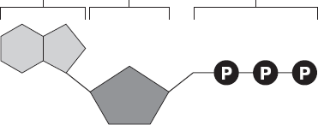

*For Questions 8–9, refer to the Visual Analogy comparing ATP to a charged battery.*

**VISUAL ANALOGY**

**8.** In the visual analogy, what chemical is represented by the low battery (use the diagram on the right)?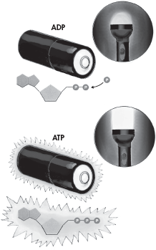

**9.** How does the diagram show an increase in energy?

**10.** What are two ways in which cells use the energy temporarily stored in ATP?

**11.** Energy is needed to add a third phosphate group to ADP to make ATP. What is a cell’s source of this energy?

**Heterotrophs and Autotrophs**

*For Questions 13–17, write True if the statement is true. If the statement is false, change the underlined word or words to make the statement true.*

**13.** All heterotrophs must eat food to get energy.

**14.** Autotrophs do not need to eat food because they make food.

**15.** The energy in food originally came from ATP.

**16.** The term photosynthesis means “pulling apart with light” in Greek.

**17.** The energy of sunlight is stored in the chemical bonds of carbohydrates.

**18.** Complete the table comparing two types of organisms.

|  |  |  |
| --- | --- | --- |
| **Autotrophs and Heterotrophs** |  |  |
| **Type** | **Description** | **List Three Examples** |
| Autotrophs |  |  |
| Heterotrophs |  |  |

**19.** Suppose that you ate a hamburger on a wheat roll with lettuce, tomatoes, and onions for lunch. As you ate, you took in food molecules from plants and animals. Explain why all the energy in the food molecules of this hamburger could be traced back to the sun.

adapted from Miller/Levine Biology 2011