Name Class Date

Ecology Unit Test
Multiple Choice
Write the letter that best answers the question or completes the statement on the line provided.
_____ 1. All the interconnected feeding relationships in an ecosystem make up a food
a. interaction. c. network.
b. chain. d. web.
_____ 2. Nitrogen fixation is carried out primarily by
a. humans. c. bacteria.
b. plants. d. consumers.
_____ 3. Animals that get energy by eating the carcasses of other animals that have been killed by predators or have died of natural causes are called
a. scavengers. c. heterotrophs.
b. omnivores. d. detritivores.
_____ 4. There are 150 Saguaro cactus plants per square kilometer in a certain area of Arizona desert. To which population characteristic does this information refer?
a. growth rate c. age structure
b. geographic range d. population density
_____ 5. The movement of organisms from one ecosystem into another ecosystem is called
a. immigration. c. population shift.
b. emigration. d. carrying capacity.
_____ 6. For most populations that are growing, as resources start to become less available, the population
a. declines rapidly. c. reaches carrying capacity.
b. increases more rapidly. d. enters a phase of exponential growth.
_____ 7. Sea otters live in the ocean. Which of the following is NOT likely to be a limiting factor on the sea otter population?
a. disease c. drought
b. competition d. predation
_____ 8. Each of the following is a density-dependent limiting factor EXCEPT
a. competition. c. crowding.
b. temperature. d. disease.
_____ 9. Which of the following is a biotic aspect of an organism’s niche?
a. the water in the area b. amount of sunlight
c. the way it gets food d. composition of soil
_____ 10. An interaction in which an animal feeds on plants is called
a. carnivory. c. predation.
b. herbivory. d. symbiosis.
_____ 11. A symbiotic relationship in which both species benefit is
a. commensalism. c. predation.
b. mutualism. d. parasitism.

_____ 12. Primary succession would most likely occur after
a. a forest fire. c. farm land is abandoned.
b. a formation of a volcanic island. d. a severe storm.
_____ 13. Using resources in way that does not cause long-term environmental harm is called
a. sustainable development.
b. monoculture.
c. biological magnification.
d. subsistence hunting.
_____ 14. Protecting an entire ecosystem ensures that
a. captive breeding programs will succeed.
b. existing parks and reserves will expand.
c. governments will set aside land.
d. interactions among many species will be preserved.
_____ 15. One type of symbiosis is
a. succession.
b. competition.
c. predation.
d. parasitism.

The diagram below shows a marine food chain.
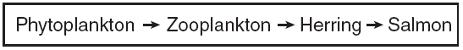

______16. The zooplankton in this food chain are….
- primary producers c. secondary consumers
- tertiary consumers d. primary consumers

A forest ecosystem food web is shown below.

______17. If additional wrens are introduced into this ecosystem, there will most likely be an immediate
decrease in the
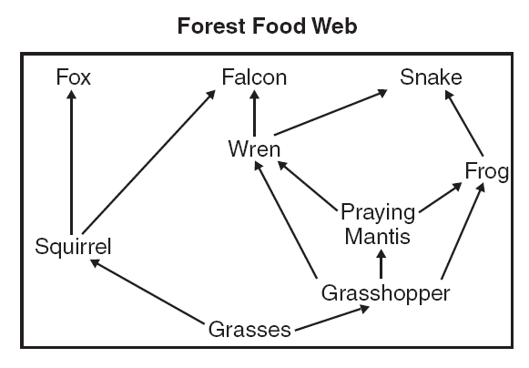
- frog population
- snake
- falcon
- grasshopper

The table below contains information about animal diets.
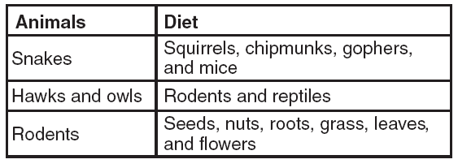

______ 18. Which energy pyramid best represents the data in the table?

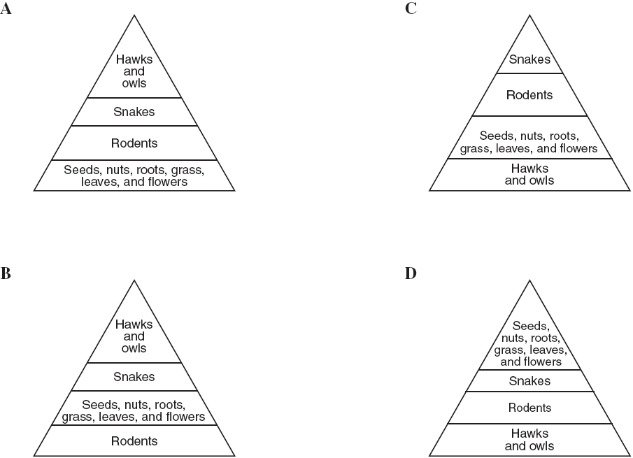

______19. Rabbits were introduced into Australia in 1859. The rabbits had no natural predators and began to
crowd the native animals out of their habitats. When this happened the rabbits became a(n) ______ species.
a. extinct c. abundant
b. invasive d. carnivorous

_____20. Most of the energy gained by consumers from eating the previous trophic level in an
ecosystem is lost as ______.
- heat c. reproduction
- metabolism d. none of the above

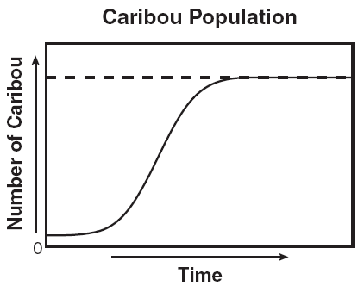
The graph to the right shows changes in caribou population over time.

______21. Based in the graph, which of the following is a possible explanation for the stabilization (leveling off) of the caribou population?
- an equal number of deaths and births.
- an unequal number of deaths and births.
- an equal number of immigrants and births.
- an unequal number of immigrants and deaths.

Short Answer
In complete sentences, write the answers to the questions on the lines provided.

22. Explain what would happen if two mouse species tried to occupy the same niche in a meadow.

____________________________________________________________________________
____________________________________________________________________________
____________________________________________________________________________

23. How do predators affect the population of their prey?

_____________________________________________________________________________
_____________________________________________________________________________
_____________________________________________________________________________
_____________________________________________________________________________

24. What is a limiting factor? Give one example.
_____________________________________________________________________________
_____________________________________________________________________________
_____________________________________________________________________________

25. Figure 4–3 Characteristics of Different Biomes
Biome | Temperatures | Precipitation | Soil Quality
Tropical Rain Forest | hot year-round | wet year-round | thin, nutrient-poor
Tropical Dry Forest | warm year-round | alternating wet and dry seasons | rich
Tropical Grassland/  Savanna/Shrubland | warm | seasonal rainfall | compact
Desert | variable | low precipitation | rich in minerals but poor in  organic material
Temperate Grassland | warm to hot summers;  cold winters | moderate and seasonal | fertile
Temperate Woodland  and Shrubland | hot summers, cool winters | dry summers; moist winters | thin, nutrient-poor
Temperate Forest | warm summers;  cold to moderate winters | stable year-round | fertile
Northwestern  Coniferous Forest | mild temperatures | dry summers; abundant precipitation  in the fall, winter, and spring | rocky, acidic
Boreal Forest | short mild summers;  long cold winters | moderate precipitation | acidic, nutrient-poor
Tundra | short summers; long, cold,  dark winters | low precipitation | poorly developed

26. Interpret Tables Which biomes in Figure 4–3 have a relatively stable amount of precipitation all year long?

27. Analyze Data Which biomes in Figure 4–3 have little variation in temperatures during the year?

Population Statistics in the United States From 1900 to 1990 Figure 5–2
 | 1900 | 1910 | 1920 | 1930 | 1940 | 1950 | 1960 | 1970 | 1980 | 1990
Live births per thousand | 32.3 | 30.1 | 27.7 | 21.3 | 19.4 | 24.1 | 23.7 | 18.4 | 15.9 | 15.6
Deaths per thousand | 17.1 | 14.7 | 13.0 | 11.3 | 10.8 | 9.6 | 9.5 | 9.5 | 8.8 | 8.7
Number of births over deaths | 15.2 | 15.4 | 14.7 | 10.0 | 8.6 | 14.5 | 14.2 | 8.9 | 7.1 | 6.9
Life expectancy at birth (yrs) | 47.3 | 50.0 | 54.1 | 59.7 | 62.9 | 68.2 | 69.7 | 70.8 | 73.7 | 74.8
Increase in longevity since 1900 (yrs) |  | 2.7 | 6.8 | 12.4 | 15.6 | 20.9 | 22.4 | 23.5 | 26.4 | 27.5

28. Interpret Tables According to Figure 5–2, which year had the highest number of live births per thousand of population?
____________
29. Analyze Data Compare the number of deaths per thousand in 1960 and 1970 as shown in Figure 5–2.
____________

30. Interpret Tables In which year was the number of births over deaths at its lowest point, according to Figure 5–2?
____________

31. Draw Conclusions What is one possible explanation for the trend in number 30? __________________________
______________________________________________________________________________________________
32. Compare and contrast primary succession and secondary succession and give an example of each.

________________________________________________________________________________________________________________________________________________________________________
____________________________________________________________________________________________________________________________________________________________________________________________________________________________________________________________

33. Choose one local invasive species and describe its effect on our ecosystem.
_______________________________________________________________________________________________
_____________________________________________________________________________________________________________________________________________________________________________________________________________________________________________________________________________________________

34. Describe one negative affect that agriculture may have on water quality and pose at least one possible solution to the problem.
_____________________________________________________________________________________________________________________________________________________________________________________________________________________________________________________________________________________________
_______________________________________________________________________________________________

