Problem 6.1
> restart;
> with(LinearAlgebra):
> N:= 10;

> A:=Matrix(N):
for i from 1 to N
do
for j from 1 to N
do A[i,j] := evalf(1/(i+j-1)):
od:
od:
> A:
Part 1
> Vt,U := SingularValues(A,output=['Vt','U']):
> S:= SingularValues(A);
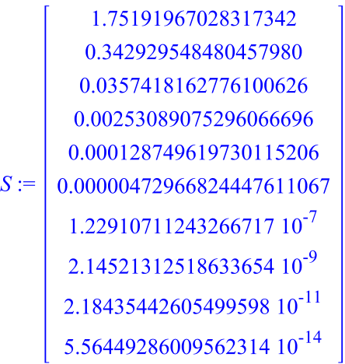
> Diag:= DiagonalMatrix(S):
Part 2
> B:=MatrixMatrixMultiply(MatrixMatrixMultiply(Transpose(Vt),Diag),Transpose(U)):
> MatrixNorm(A-B,1);
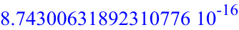
Part 3
> for N from 1 to 40 do
A:= Matrix(N);
for i from 1 to N
do
for j from 1 to N
do A[i,j] := evalf(1/(i+j-1)):
od:
od:
print(N,ConditionNumber(A));
od:
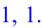
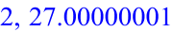
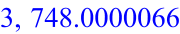
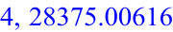
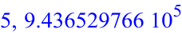
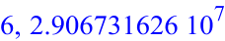
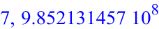
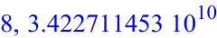
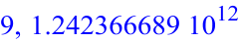
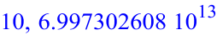
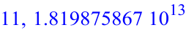
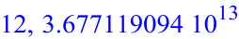
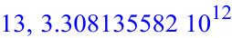
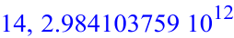
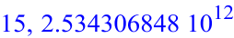
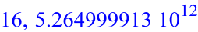
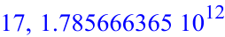
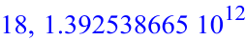
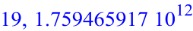
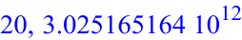
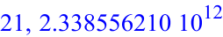
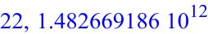
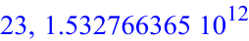
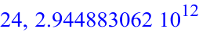
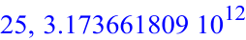
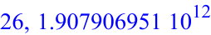
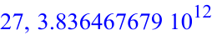
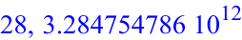
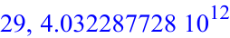
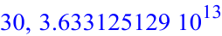
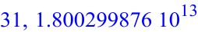
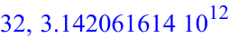
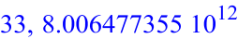
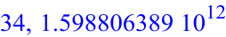
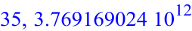
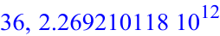
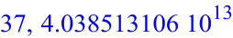
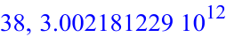
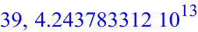
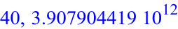
>
Part 4
> Digits:=60;
for N from 1 to 40 do
A:= Matrix(N);
for i from 1 to N
do
for j from 1 to N
do A[i,j] := evalf(1/(i+j-1)):
od:
od:
print(N,ConditionNumber(A));
od:

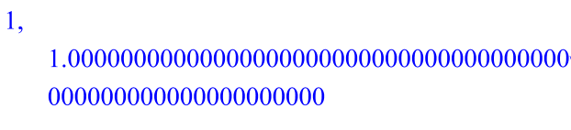
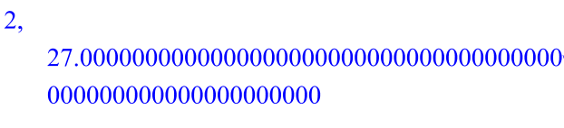
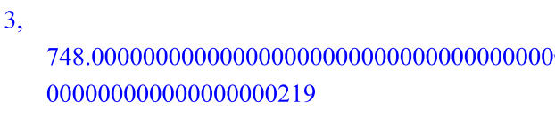
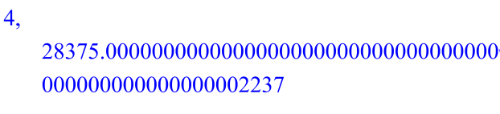
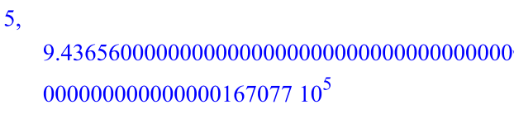
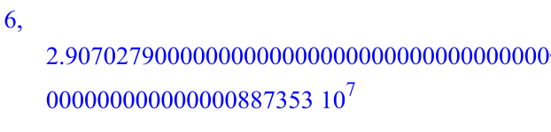
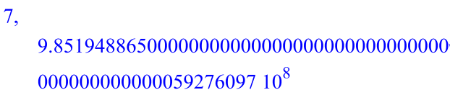
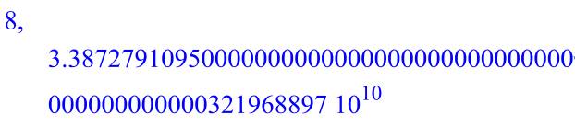
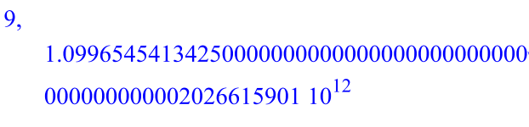
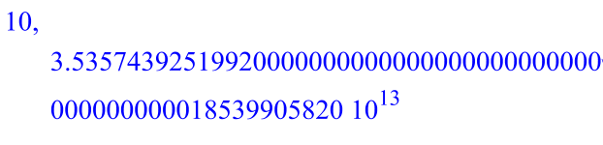
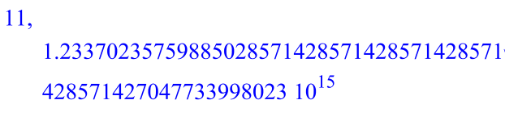
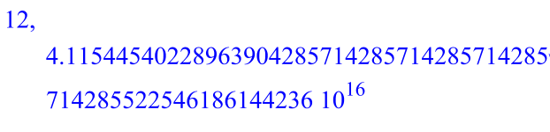
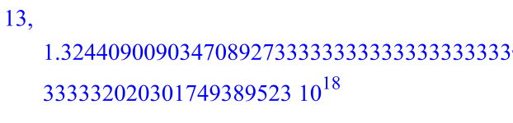
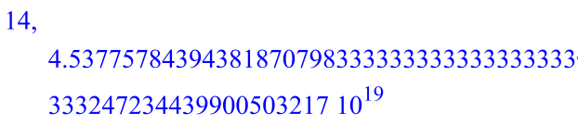
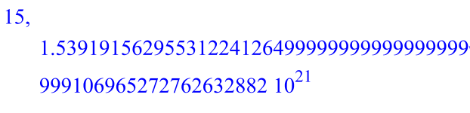
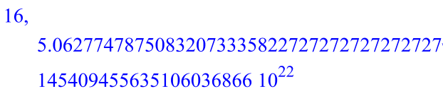
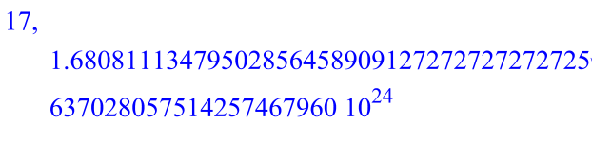
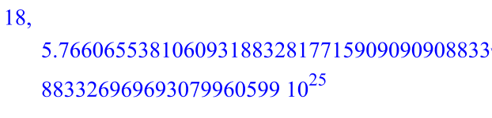
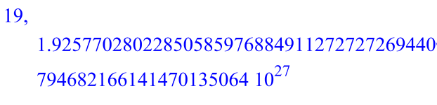
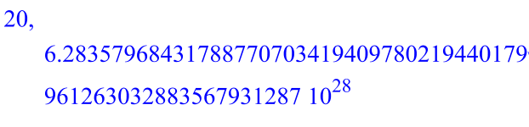
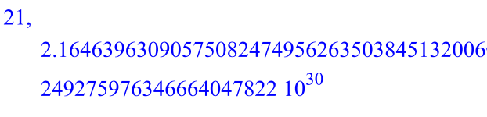
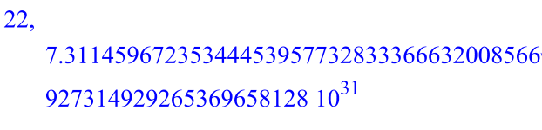
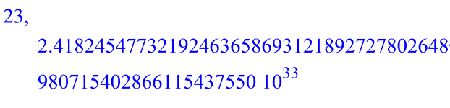
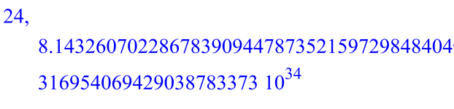
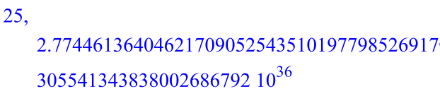
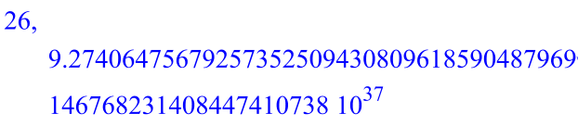
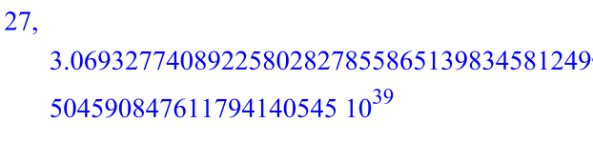
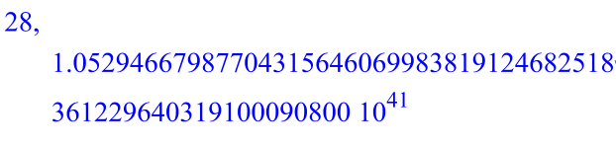
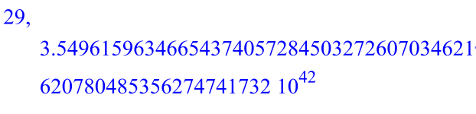
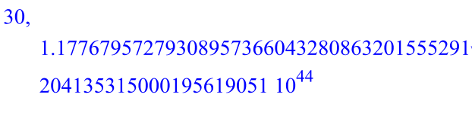
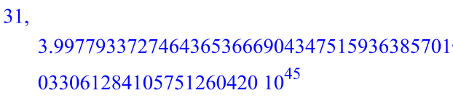
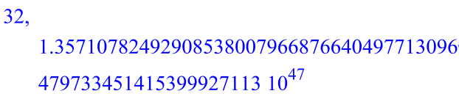
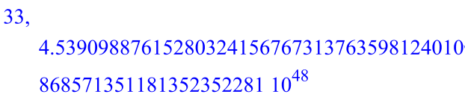
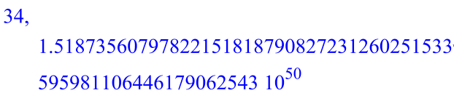
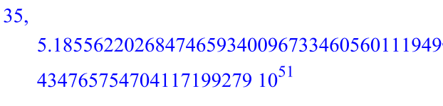
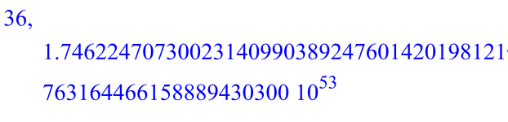
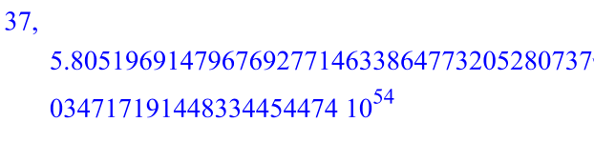
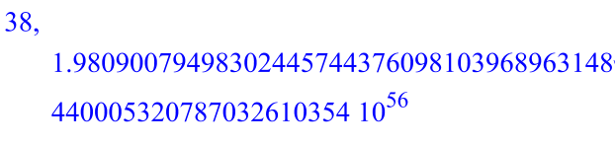
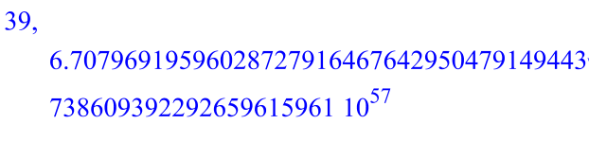
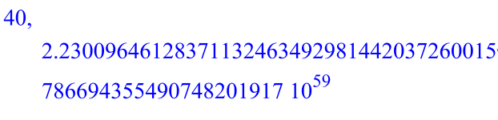
>
Part 5
The solutions of Ax=b may lose as much as log_10(cond(A)) digits.
If you only have 10 digits, and the condition number is > 10^(10), you
may have no digits of accuracy left.

>

