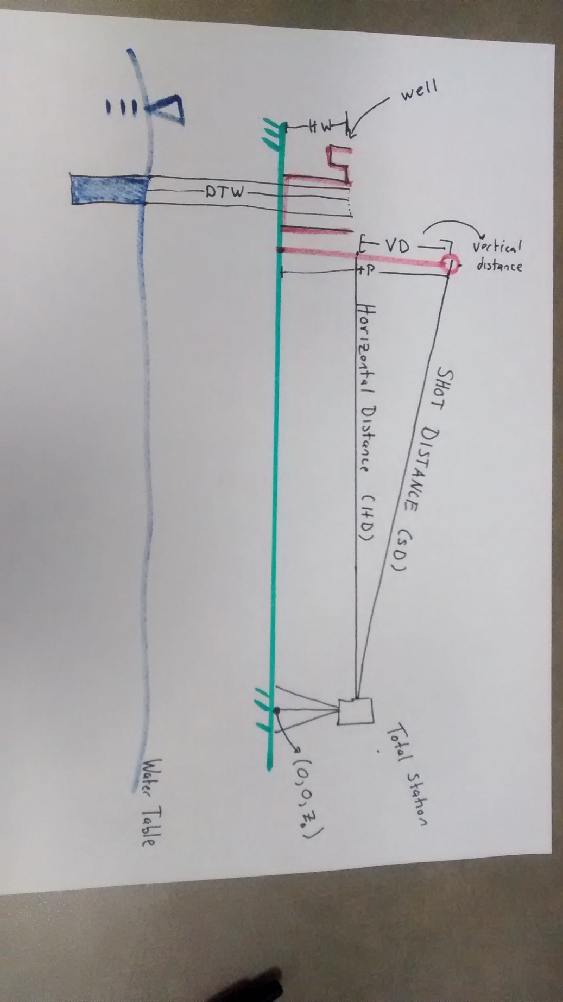

**Total Station Set-Up and Use:**

1. Set up tripod on a flat location; secure Total Station (TS) to tripod via screw on top of tripod
2. Use height adjustment dials at the bottom of TS to level TS (bubble should be in center of circle)
3. Measure height of TS from ground (markers located on TS sides)
4. Insert battery on TS side (pins on battery face down)
5. Turn on TS and Press PRG (program)
6. Use Compass to find North, rotate TS northward
7. Zero the TS by pressing 0SET, waiting for 0SET to flash, and press 0SET again
8. Optional: Change units of distance measurements. Click the X in top right of TS screen, press Config, Change Units

**Take Distance and Angle Measurements in Well Field:**

1. One Student should take Prism and stand next to well. Prism should be leveled
2. Set Prism height above all nearby vegetation (about 6ft)
3. Point TS to Prism and then lock TS
4. Focus TS, and use fine tune dials to point TS directly at Prism. Note when looking through the scope a bulls-eye should be visible, if not visible turn dial located on scope
5. When Prism is in bulls-eye, Press Measure button and retrieve Vertical/Horizontal/ Shot distances, and Horizontal/Vertical angles.

**Coordinate Calculations**

To find x,y coordinates of wells use cos/sin of angle *Horizontal distance

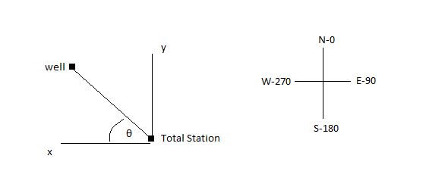E.g.

Horizontal Angle = 290, HD =Horizontal Distance

Since we are in quadrant 4: θ = Horizontal Angle -270= 290-270 =20

x = HD*cos(θ), y=HD*sin(θ)

*Note: If you are in quadrant 3 (180<HA<270); θ=270-HA

Find height of ground relative to Total Station

See Diagram Above:

* Choose z0 as the height of the ground at the Total Station (z0 can be any value and is the height relative to an arbitrary datum)
* Find the height of the Prism relative to z0, hp.
  + hp= z0+ height of Total Station + Vertical Distance
  + hp= z0+ TS + VD
* Then the ground level at well is the height of the prism relative to z0 minus the length of the prism
  + zwell =hp –HP, where HP is the height from the ground to prism

Now we have x,y,z coordinates for each well

**Determine the water Table Level**

1. Measure the height from the surface to the top of the well
2. Lower the water level meter into the well until a beep is heard. Record the distance from the top of the well to water table. Repeat for accuracy.

**Calculation for Water Table height relative to z0:**

* Water Table = height of ground level at well + well height – distance from well top to water table
  + Water Table = zwell + HW – DWT: HW is well height, DWT, distance to Water table

**Slug Test**

1. Lower pressure sensor below the water table
2. Inflate tube with bike pump (about 5 pumps) and close valve: Ensure tube is above the water table
3. Poor slug (water) down well. The inflated tube will prevent water from reaching the pressure sensor, and hence pressure will remain relatively constant
4. Release pump valve, thereby deflating the tube and causing the slug to drop on the pressure sensor. (We will see a spike in pressure)
5. Find hydraulic conductivity from change in pressure over time:

**Water Quality Test:**

1. Insert Tube into pump clamp
2. Turn on pump and choose direction of flow. To change flow direction, push right arrow on keypad and then choose cyclical/anti-cyclical option
3. Prime the water for 15s by pressing ‘fast forward’ button. This allows us to sample aquifer water.
4. Press the ‘Play’ button to slow down the rate of pumping and collect water in test tube. Make sure the top of tube has a meniscus.