Concert Program Printing Instructions

The title page and special thanks highlighted material (both on page 2 of this word document) should be modified for your specific concert and highlighting removed.

The program can be printed in color or grayscale. Colored paper is an easy addition without paying for colored printing.

To print, select ‘double sided printing’, ‘flip on short side’, and print pages 2-5 (to exclude page 1, in these instructions). This way, 2 and 3 will be back-to-back and 4 and 5 will be back-to-back.

Ultimately, two sheets of paper with double sided printing will be folded in half to make a booklet with eight pages.

Page 2 is the outer cover of the booklet.

Page 3 is the inside of the outer cover.

Page 4 is the outside of the insert.

Page 5 is the inside of the insert.

The folded booklet page order will be:

1-Front: Cover page with Glee Club logo

2-About the Notre Dame Glee Club

3-2014 Fall Tour Program

4-Sacred Millenium

5-Spirituals

6-Tenor I

7-Baritone

8-Back: Notre Dame Glee Club 2014-2015 Officers

If you have any questions please contact Publicity Manager Joseph Copp (jcopp1@nd.edu) or Tour Manager TJ Dean (tdean@nd.edu).

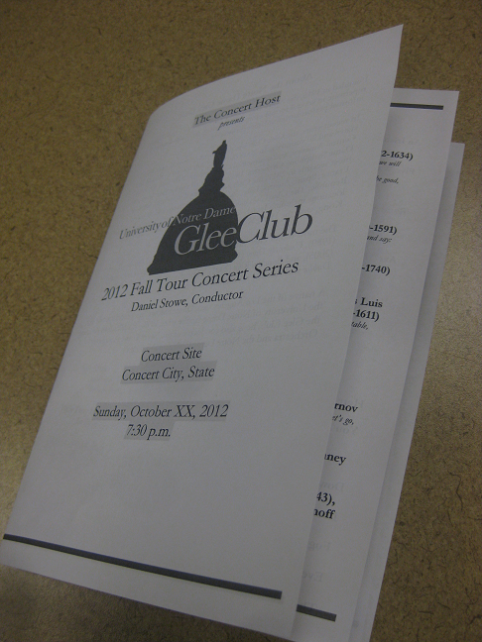

**Notre Dame Glee Club 2014 – 2015**

Officers and Administration

President..........................................................................................Paul Kearney

Vice Presidents ..................................................Nick Goldsmith and TJ Dean

Secretary.............................................................................................Stuart Streit

Treasurer............................................................................................Ollie Hanes

Business Manager...................................................................................TJ Dean

Alumni Representative .............................................................Brendan Evans

Director...........................................................................................Daniel Stowe

For up-to-date information, concert dates, and merchandise sales including our full recordings catalogue, visit

**http://gleeclub.nd.edu/**

**The Notre Dame Glee Club**

Crowley Hall of Music

Notre Dame IN 46556-5643

Facebook: Notre Dame Glee Club



Twitter: @NDGleeClub



**Special Thanks:**

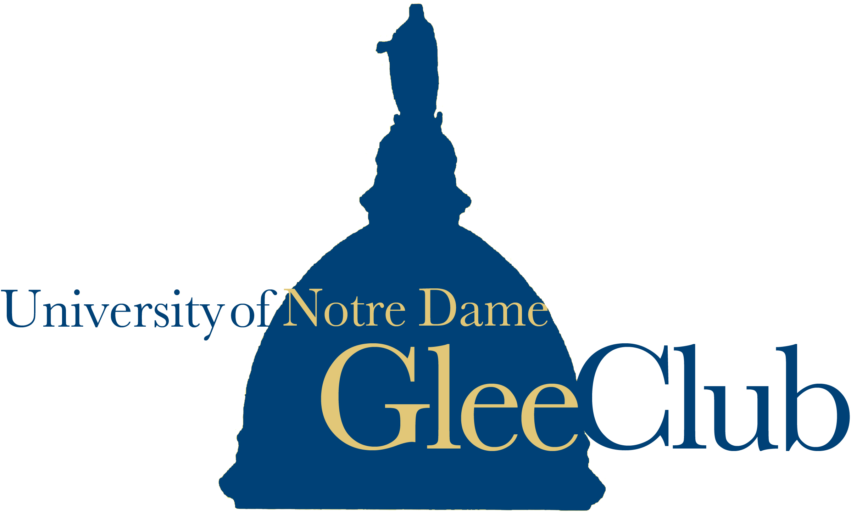

The Concert Host

*presents*



2014 Fall Tour Concert Series

Daniel Stowe, Conductor

Concert Site

Concert City, State

Weekday, October XX, 2014

7:30 p.m.

**About the Notre Dame Glee Club**

Founded in 1915, the Notre Dame Glee Club presents a broad repertoire of classical, religious, folk, and barbershop works in several formal campus concerts as well as in dozens of informal performances at University events.

In recent years, the Glee Club has performed on tour in over 40 U.S. states and 20 countries. In 2005 the Glee Club toured in Mexico and Central America, and returned to Guatemala in 2009 with the Notre Dame Symphony Orchestra. In the course of regular European tours, most recently in 2011, the Club has performed in Ireland, England, France, Spain, Austria, Italy, Switzerland, Germany, and the Czech Republic. The Glee Club has also performed in many other international locations including Israel, with the Jerusalem Symphony, and Hong Kong, with the Hong Kong Sinfonietta.

The most recent Glee Club recordings include *Shake Down the Thunder* (1989), *Under the Dome* (1999), *In dulci jubilo* (2001), *Vive la compagnie* (2005), and *Beautiful Rain* (2007). The newest CD, *On the Rocky Road to Dublin* was released in the Fall of 2012.

**Daniel Stowe** has been a member of the University of Notre Dame faculty since 1993. In addition to directing the Glee Club, he is also conductor of the Notre Dame Symphony Orchestra and the Notre Dame Collegium Musicum.

|  |  |  |  |
| --- | --- | --- | --- |
| **Baritone** |  |  |  |
| Nicholas Barella | First Year | Business | Glen Ellyn, IL |
| Jonathan Bartolome | First Year | Biochemistry | Bolingbrook, IL |
| Joseph Copp | Senior | Chemical Engineering | Tulsa, OK |
| Christian Gorski | Sophomore | Physics | Mokena, IL |
| Oliver Hanes | Junior | Electrical Engineering | Wilmington, DE |
| Collin Hubler | Junior | Biology (Pre-Medical) | Brookfield, WI |
| Caleb Johnson | Sophomore | A.C.M.S. | Loves Park, IL |
| Jay Johnstone | Senior | Chemical Engineering | Birmingham, AL |
| Hunter Kuffel | Sophomore | Economics/English | Geneseo, IL |
| John Linczer | First Year | Arts & Letters Pre-Medical | South Bend, IN |
| Ryan McMullen | Sophomore | Computer Science | Medina, OH |
| Steve Perry | Senior | Theology/Psychology | Cleveland, OH |
| Brian Richman | First Year | Finance | Mishawaka, IN |
| Joey Schachner | Sophomore | Biochemistry | Charlotte, NC |
| Stephen Spittler | First Year | Chemical Engineering | Wheaton, IL |
| Benjamin Swanson | Sophomore | Music/Theology | Lincoln, NE |
| Merrick Topping | Junior | Finance/A.C.M.S. | Glenview, IL |
| Ryan Wiegand | Junior | Political Science | Carmel, IN |
| **Bass** |  |  |  |
| Christianos Burlotos | First Year | Mechanical Engineering | Richfield, OH |
| Gregory Corning | First Year | Science-Business | Wethersfield, CT |
| Walker Embrey | Sophomore | Chemical Engineering | Irving, TX |
| Brendan Evans | Senior | Economics | Granger, IN |
| Nicolas Garcia | Sophomore | Electrical Engineering | Tome, NM |
| Marc Gazda | Senior | Architecture | Framingham, MA |
| Michael Gregory | Junior | Mechanical Engineering | Frienswood, TX |
| Paul Kuczynski | Senior | English | Bay City, MI |
| Patrick Lyon | Sophomore | Program of Liberal Studies | Granger, IN |
| Jack McKeegan | Sophomore | Science Pre-Professional/Spanish | McMinnville, OR |
| Michael Moss | Sophomore | Political Science | Shoreview, MN |
| Anthony Murphy | Junior | Film, Television, & Theatre | Grand Rapids, MI |
| Nicholas Pennington | First Year | Computer Science | Jacksonville, IL |
| Stuart Streit | Junior | English/Economics | Crystal Lake, IL |
| Kevin Warten | First Year | Mechanical Engineering | Fairfield, CT |
| Matt Williams | First Year | Environmental Engineering | San Clemente, CA |
| **Tenor I** |  |  |  |
| Ricardo Castañeda | Sophomore | Business | Oak Park, IL |
| Soren Kyhl | First Year | Engineering | Des Moines, IA |
| Daniel Le | Junior | Business | Beaverton, OR |
| Bruno Mediate | Sophomore | Film, Television, & Theatre | Colorado Springs, CO |
| Joseph Ong | Junior | Chemistry/Chinese | Rancho Palos Verdes, CA |
| Michael Prough | Senior | Biochemistry | Goshen, IN |
| Michael Shakour | Senior | Program of Liberal Studies/Theology | South Bend, IN |
| Hunbo Shim | Senior | Accounting/Chinese | Fullerton, CA |
| Andrew Spitzer | First Year | Chemical Engineering | Marion, IN |
| Francesco Tassi | First Year | International Economics | Florence, Italy |
| Jamie Towey | Senior | Arabic/Chinese | Ave Maria, FL |
| **Tenor II** |  |  |  |
| James Argue | Sophomore | History/Political Science | Rochester, MI |
| Maxwell Bullard | Graduate Student | Psychology | Southlake, TX |
| TJ Dean | Senior | Management Consulting/Vocal Performance | Carmel, IN |
| Matthew Dohohue | First Year | History/Political Science | Denver, CO |
| Patrick Fasano | Junior | Physics | Monmouth, IL |
| Nick Goldsmith | Senior | Business/Music | Des Moines, IA |
| Paul Kearney | Senior | History/Art History | Worcester, MA |
| Erik Klaus | Sophomore | Mechanical Engineering | Marysville, OH |
| James O'Connor | Senior | Finance/Chinese | Leawood, KS |
| Joel Ostdiek | Junior | Business | Columbus, NE |
| Zach Osterholz | Senior | Biology (Pre-Veterinary) | East Dubuque, IL |
| Daniel Pedroza | Sophomore | Economics/Psychology | Ciudad Juarez, Mexico / El Paso, Texas |
| Rahul Ramani | First Year | Science-Business (Pre-Medical) | Clarendon Hills, IL |
| Tony Stedge | Junior | Mechanical Engineering | Puyallup, WA |
| Carlos Torres | Sophomore | Finance/Mathematics | Katy, Texas |
| Christopher Torres | Senior | Physics | Sterling Heights, MI |
|  |  |  |  |

**Notre Dame Glee Club**

**Fall Tour Program 2014**

**Swing Down Chariot Spiritual, arr. The Golden**

**Gate Quartet**

* * * * *

**I. Music of Felix Mendelssohn (1809-1847)**

**Two Sacred Choruses, op. 115**

**Periti autem**

And those who are wise will shine like the brightness of the firmament; and those who turn many to righteousness, like the stars forever. (Daniel 12:3)

**Beati mortui**

“Blessed are the dead, who die in the Lord henceforth.” “Yes,” says the Spirit, “thus they will rest from their labors, for their works follow them.” (Revelation 14:13)

***From* Four Songs, op. 75**

**Abendstänchen (Serenade)**

Sleep, my dearest, for here on earth it is now so quiet and still! The golden flocks graze above, and over us all watches the shepherd.

These tones twine in and out around tree and branch in your quiet little room, climbing as if on golden ladder

And the sound of these tones is carried far away on a caressing breeze, and through wall and lock, I hope, my sweet child hears them in her dreams. (Eichendorff)

**Trinklied (Drinking Song)**

As long as a man is sober he finds bad things to his liking; when he has been drinking, then he knows what’s right. But overindulgence is only a glass away; Hafiz, do teach me how you understand the matter.

For my opinion is no exaggeration: a man who can’t drink shouldn’t fall in love. But you drinkers shouldn’t boast of this; a man who can’t fall in love shouldn’t drink. (Goethe)

**II. A Sacred Millenium**

**Exaudi Deus** **Giovanni Gabrieli (c. 1555-1612)**

Give ear to my prayer, Lord, and do not hide from my supplication. Attend to me, and answer me; I am overcome by my trouble. I am distraught by the noise of the enemy, because of the oppression of the wicked. For they bring trouble upon me, and in anger they cherish enmity against me. (Psalm 55: 1-3)

**Benedicamus Domino (Notre Dame organum) Anonymous (c. 1200)**

Let us bless the Lord. Thanks be to God.

**Benedicamus Domino (Organum and Psalm) Krzysztof Penderecki (b.1933)**

Let us bless the Lord. Praise the Lord, all nations; praise him, all peoples. For His mercy is bestowed upon us, and His faithfulness endures forever. Alleluia.

**III. English Romantic Partsongs**

**Quick! We Have But a Second Charles Villiers Stanford**

**(1852-1924)**

**Autumn Leaves Charles Villiers Stanford**

**Thou Didst Delight Mine Eyes Gerald Finzi (1901-1956)**

**The Long Day Closes Arthur Sullivan (1842-1900)**

* * * * *

**Ave Maria (Angelus Domini) Franz Biebl (1906-2001)**

The angel of the Lord appeared to Mary and she conceived by the Holy Spirit.

Hail Mary, full of grace, the Lord is with you, blessed are you among women, and blessed is the fruit of your womb, Jesus.

Mary said: “Behold, the maidservant of the Lord, let it be done to me according to your word.” And the Word was made flesh, and lived among us.

Holy Mary, Mother of God, intercede for us now and in the moment of our death. Amen.

***Intermission***

**IV. Spirituals**

**Old Time Religion Arr. Brian Dean ‘02**

**Swing Low Sweet Chariot Arr. William Dawson**

**Wade in the Water Arr. Patrick Quigley ‘00**

**Hold On! Arr. Eugene Thamon Simpson**

**V. Work Songs**

**From *Sunshine on My Shoulder* Arr. Ralph DeCormier**

**Sunshine on My Shoulder**

**Another Man Done Gone**

**Ragged Leevy Arr. David Morrow**

**VI. *The Music Man*, Barbershop Style**

**(Music and Lyrics by Meredith Willson)**

**The Wells Fargo Wagon**

**(Ya Got) Trouble**

**The Sadder-But-Wiser Girl**

**Lida Rose**

**Seventy-Six Trombones**

* * * * *

**Danny Boy arr. Patrick Quigley**

**Notre Dame, We Hail Thee Rev. Eugene Burke**

**& Daniel Pedtke**

**Notre Dame, Our Mother O’Donnell/Casasanta**

**arr. Isele**

**The Notre Dame Victory March John F. Shea**

**& Michael Shea, C.S.C.**