[sponsor] Presents

The University of Notre Dame Glee Club
In concert

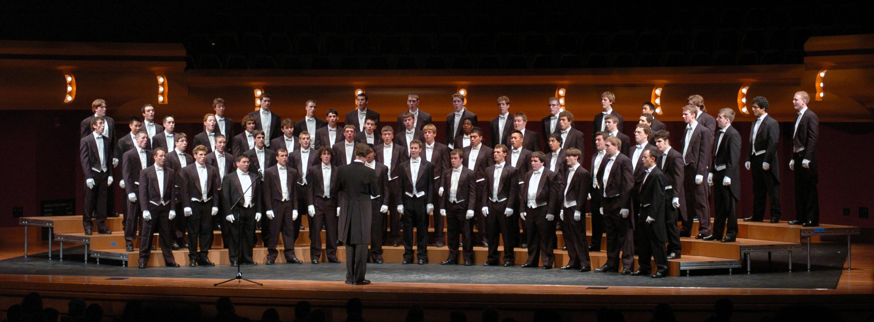

Classical Music * Spirituals * Folk Songs
Songs of Notre Dame

(TIMe)
(place)
(admission price—contact info)

