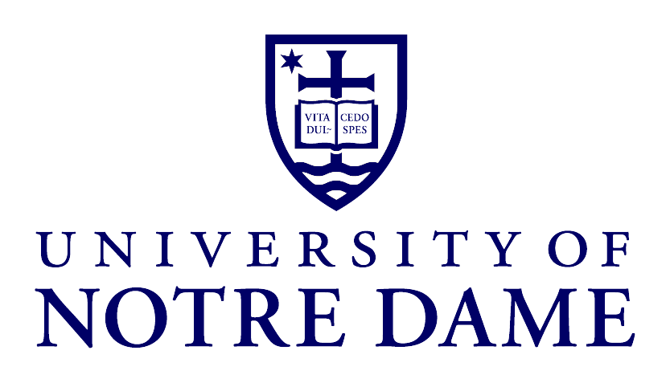

The Notre Dame Symphony Orchestra
The Notre Dame Glee Club
DeBartolo Center for the Performing Arts

Daniel Stowe, conductor
102 Performing Arts Center
Notre Dame, IN 46556-4600
Tel (574) 631-9457; Fax (574) 631-9411
E-mail: dstowe@nd.edu

RADIO: PUBLIC SERVICE ANNOUNCEMENT

Contact: TJ Dean
Tour Manager
University of Notre Dame Glee Club
tdean@nd.edu
Office (574) 631-6352
http://gleeclub.nd.edu

Issued: November, 2014

Radio Public Service Announcement
(duration about 00:30 seconds)

The University of Notre Dame Glee Club, directed by Daniel Stowe, will present a concert of choral music for men’s voices on [date] at [time] at [venue name and address].
Tickets are available at the door or by calling [phone number, if applicable].

The seventy-voice Glee Club begins their centennial year in the fall of 2014. The concert program for their spring 2015 tour will include classical a cappella (ah- cah- PEL- lah) music for men’s chorus, the Club will present folk songs, African-American spirituals, barbershop arrangements, and songs of Notre Dame. Particularly noteworthy will be the premiere performances of two newly-commissioned works: a pair of sea shanty arrangements by Tim Takach, founding member of the premier men’s ensemble Cantus, and a poetic setting by Pulitzer Prize finalist and Chicago Symphony Composer-in-Residence Augusta Read Thomas.

