**Biology - Unit 8 Teacher Notes**

**DNA and Protein Synthesis**

DNA and Protein Synthesis are now at the heart of biology, however this was not always the case. Prior to 1950, scientists did not know that DNA was the genetic material. For this reason we have put DNA and Protein Synthesis near the end of the Biology Modeling curriculum. It is also the part of the curriculum that is very abstract and hard for students to understand.

DNA and Protein Synthesis relates to the story that we are telling through the following question:

* If life is so closely interconnected, why are organisms so diverse?

DNA and its communication with other parts of the cell in order to maintain life are integral at answering this question and keeps with the overall arching question of “What is life and how is it interconnected?”

We’ll use 2 principles to guide us in the development of the DNA and Protein Synthesis concept.

1. DNA is the information that must be replicated in order to maintain continuity.
2. The information must come from DNA to build proteins that carry on the work of the cell.

# Essential question: If life is so closely interconnected then why are organisms so diverse?

# Instructional goals

This module will be separated into two different paradigms:

I. What is DNA and how does it copy itself?

II How does DNA communicate and build proteins?

-What happens if the communication goes wrong (mutations)?

Develop a cause-and-effect model relating the structure of DNA to the function of protein synthesis:

1. Draw a diagram of nucleotides, using the concept of base pairing to construct the DNA ladder.

2. Be able to state the following about the model of the DNA molecule: (RECOPY)

a. is made of two strands wound about each other in a double helix.

b. each strand is made up of a chain of nucleotides. the side of the ladder is alternating sugar and phosphate groups bonded together.

c. the bases are attached only to the sugar molecules.

d. the two strands are held together by weak hydrogen bonds.

e. nucleotides pair up in a specific way.

3. Using a model, explain how DNA replication in cells and hereditary coding.

4. Explain the steps of the replication process (coping DNA).

5. Describe the relationship of the sequence of nucleotides in DNA and how that sequence codes for proteins, which is central key to cell function and life.

6. Explain the process of protein synthesis:

Transcription that produces an RNA copy of DNA, which is further modified into the three types of RNA. mRNA traveling to the ribosome (rRNA)

Translation – tRNA supplies appropriate amino acids.

7. Interpret a codon chart to determine the amino acid sequence produced by a particular sequence of bases.

8. Explain how an amino acid sequence forms a protein that leads to a particular function and phenotype (trait) in an organism.

9. Describe two roles that proteins play in organisms.

Proteins can be structural (forming a part of the cell materials) or functional (hormones,

enzymes, or chemicals involved in cell chemistry).

10. Create a model of how DNA communicates the plan of how to make a protein.

11. Analyze what might cause a difference in the plan DNA has set out.

**Goal (Standard #)**

B.5.2 Describe how hereditary information passed from parents to offspring is encoded in regions of DNA molecules called genes.

B.5.3 Describe the process by which DNA directs the production of protein within a cell.

B.5.5 Understand that proteins are responsible for the observable traits of an organism and for most of the functions within an organism.

B.5.4 Explain how the unique shape and activity of each protein is determined by the sequence of its amino acids.

B.5.6 Recognize that traits can be structural, physiological or behavioral and can include readily observable characteristics at the organismal level or less recognizable features at the molecular and cellular level.

B.7.4 Explain the process by which a cell copies its DNA and identify factors that can damage DNA and cause changes in its nucleotide sequence.

B.7.5 Explain and demonstrate how inserting, substituting or deleting segments of a DNA molecule can alter a gene, which is then passed to every cell that develops from it and that the results may be beneficial, harmful or have little or no effect on the organism.

B.8.6 Explain how genetic variation within a population (a species) can be attributed to mutations as well as a random assortment of existing genes.

# Misconceptions

DNA varies greatly between organisms.

DNA can mutate easily.

Proteins are not linked directly to DNA.

# Essential vocabulary

|  |  |  |
| --- | --- | --- |
| Peptide  Transcription  Translation  Exon  Genetic code  Codon  Rosalind Franklin | Messenger RNA  Ribosomal RNA  Transfer RNA  Anti-codon  Gene expression  Mutation | Protein synthesis  RNA polymerase  Intron  Mutagen  Gene  Watson & Crick |

# Sequence

|  |  |
| --- | --- |
| Schedule of Activities | Activities/Laboratories/Module Layout |
| 8.1 | What is DNA and how does it copy itself?  Pre-Discussion for Paradigm Lab- “Talking with DNA”  Whiteboard  -Talk about lab... time permitting. |
| 8.2 | Paradigm Lab- DNA Extractions/ Post Discussion/Whiteboard  Flip Model Homework- Hand out Chargaff’s Data and have students come up with what the data tells us. |
| 8.3 | Whiteboarding Chargaff’s Data  -Worksheet of DNA structure |
| 8.4 | Classroom Anti-Parallel DNA model and Discussion  Extension: Zipper Demo  -Worksheet looking at DNA replication (flip model-homework) |
| 8.5 | DNA replication classroom model and discussion (Whiteboarding) |
| 8.6 | Quiz  Pre-Discussion of Paradigm II/ Whiteboarding |
| 8.7 | Paradigm II Lab activity and Post Discussion/Whiteboarding |
| 8.8 | RNA/Transcription  DNA to mRNA Transcription model (NEED TO CREATE AT A LATER DATE) |
| 8.9 | Codons: Whiteboard Practice going from DNA to amino acid in small groups. Codon Bingo for extra practice. |
| 8.10 | Translation Chnop’s /Whiteboarding/Revisit Theme how are all the Chnop’s interconnected and how might they change over time? |
| 8.11 | Proteins Revisited/Whiteboarding |
| 8.12 | Putting it all Together (Can review/whiteboard/catch up if needed)/ Unit Review Worksheets |
| 8.13 | Lab Practicum - Protein Synthesis Lab (key chain) |

# Instructional notes

## 8.1- Model Development - Talking with DNA

Pre-activity discussion

Instructions

1. Hand student groups index cards with a variety of three letter words printed on them. (*The* will be capitalized as a trigger to begin every sentence with it and certain words will have a period at the end to try to signal end of the sentence)

“The” is meant to symbolize the start codon. There are more than 20 words for students to place into sentences. (see teacher handout for list of words)

2. Instruct groups to compose (in a set amount of time - suggested 5-10 minutes) as many sentences (which follow normal sentence syntax - noun and verb agreement) as possible with those words. Write sentences on group whiteboard.

Post-activity discussion - Compare sentences and explain why there is such a difference in sentence content. Why is there such a variety? Did any group come up with the same sentence? Do we see a pattern in sentence structure?

Thoughts: All sentences should begin with The like mRNA begins with AUG codon.

All words are three letters like a codon.

Many sentences should be formed by using a small number of words much like

DNA makes a tremendous variety of proteins with only 20 amino acids.

## 8.2- Model Development - DNA Extraction/Post Discussion

**Paradigm I – Lab Activity**

(adapted from Genetic Science Learning Center and The Gene School Oracle Think Quest)

Online virtual extraction: http://learn.genetics.utah.edu/content/labs/extraction/

Teacher Notes: What does DNA look like? How to extract DNA from anything.

DNA can be extracted from anything. Since DNA is the blueprint for life – all living organisms contain DNA. Suggestions are plant specimens such as strawberries (frozen strawberries are fine), broccoli, wheat germ, spinach or animal specimens such as liver or thymus. (if you would like to do human – just do a teacher sample). *Many food sources of DNA, such as grapes, also contain a lot of water. If the blended cell soup in step 1 is too watery, there won't be enough DNA to see. To fix this, go back to step 1 and add less water. The cell soup should be opaque, meaning that you can't see through it.*

Pose questions to students: Where is DNA found? How can we get to it? What do we need to get rid of to get to the DNA? What materials do we need to accomplish this task?

Needed materials: blender or use alternative sealable sandwich baggie, salt, cold water, cheesecloth or strainer, funnel, test tube, meat tenderizer, clear liquid dishwashing detergent ((look for sodium laurel sulfate in the ingredients), cold alcohol (91-95%); wooden stick (skewer), glass stirring rod, or disposable inoculating loop; graduated cylinder

Put in a blender:

* 1/2 cup of split peas or other material (100ml)
* 1/8 teaspoon table salt (less than 1ml)
* 1 cup cold water (200ml)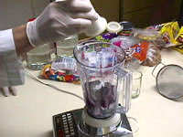

*Why is cold important? Using ice-cold water and ice-cold alcohol will increase your yield of DNA. The cold water protects the DNA by slowing down enzymes that can break it apart. Why would a cell contain enzymes that destroy DNA? These enzymes are present in the cell cytoplasm (not the nucleus) to destroy the DNA of viruses that may enter our cells and make us sick. A cell's DNA is usually protected from such enzymes (called DNases) by the nuclear membrane, but adding detergent destroys that membrane. The cold alcohol helps the DNA precipitate (solidify and appear) more quickly.*

*Salty water helps the DNA precipitate (solidify and appear) when alcohol is added.*

Blend on high for 15 seconds. For alternative to blender - Place one strawberry in a plastic sandwich bag. Smash/grind up the strawberry using your fist and finger for 2 minutes. Careful not to break the bag!! Add the provided 10mL of extraction buffer (salt and soap solution) to the bag. Kneed/mush the strawberry in the bag again for 1 minute. *DNA extraction buffer (900mL water, 50mL dishwashing detergent, 2 teaspoons salt)*

The blender separates the cells from each other, so you now have a really thin cell soup.

Pour your cell soup through a strainer into another container (like a measuring cup).  
 Add 2 tablespoons liquid detergent (about 30ml) and swirl to mix.  
  
 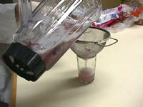

Let the mixture sit for 5-10 minutes. \* important - do not shorten

*If the cell and nuclear membranes are still intact, the DNA will be stuck in the bottom layer. Or, try letting the test tube of pea mixture and alcohol sit for 30-60 minutes. You may see more DNA precipitate into the alcohol layer over time.* Pour the mixture into test tubes or other small glass containers, each about 1/3 full.

Add a pinch of enzymes to each test tube and stir gently. Be careful! If you stir too hard, you'll break up the DNA, making it harder to see.

Use meat tenderizer for enzymes. If you can't find tenderizer, try using pineapple juice or contact lens cleaning solution.

*The two most common enzymes used in meat tenderizer are Bromelain and Papain. These two enzymes are extracted from pineapple and papaya, respectively. They are both proteases, meaning they break apart proteins. Enzymatic cleaning solutions for contact lenses also contain proteases to remove protein build-up. If you use pineapple juice or contact lens cleaning solution - just use a few drops.*

Tilt your test tube and slowly pour rubbing alcohol (70-95% isopropyl or ethyl alcohol) into the tube down the side so that it forms a layer on top of the pea mixture. Pour until you have about the same amount of alcohol in the tube as pea mixture.

Alcohol is less dense than water, so it floats on top. Look for clumps of white stringy stuff where the water and alcohol layers meet.

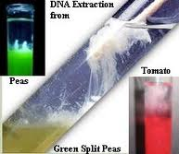

*DNA precipitates when in the presence of alcohol, which means it doesn't dissolve in alcohol. This causes the DNA to clump together when there is a lot of it. And, usually, cells contain a lot of it!*

What is the white stringy stuff? DNA is a long, stringy molecule. The salt that you added in step one helps it stick together. So what you see are clumps of tangled DNA molecules!

DNA normally stays dissolved in water, but when salty DNA comes in contact with alcohol it becomes undissolved. This is called precipitation. The physical force of the DNA clumping together as it precipitates pulls more strands along with it as it rises into the alcohol.

You can use a wooden stick or a straw to collect the DNA. If you want to save your DNA, you can transfer it to a small container filled with alcohol. *The white stringy stuff is actually a mixture of DNA and RNA. Your DNA may last for years if you store it in alcohol in a tightly-sealed container. If it is shaken, the DNA strands will break into smaller pieces, making the DNA harder to see. If it disappears it's likely because enzymes are still present that are breaking apart the DNA in your sample.*

*Cells with more chromosomes contain relatively more DNA, but the difference will not likely be noticeable to the eye. The amount of DNA you will see depends more on the ratio of DNA to cell volume. (strawberries are octoploid - so there is lots of DNA to see)*

*Extensions: Experiment with other DNA sources. Which source gives you the most DNA? How can you compare them?*

*Experiment with different soaps and detergents. Do powdered soaps work as well as liquid detergents? How about shampoo or body scrub?*

*Experiment with leaving out or changing steps. We've told you that you need each step, but is this true? Find out for yourself. Try leaving out a step or changing how much of each ingredient you use.*

*Do only living organisms contain DNA? Try extracting DNA from things that you think might not have DNA.*

**Videos:**

How to extract DNA from a Strawberry - <http://www.youtube.com/watch?v=DGnmofoKmHQ&feature=related>

***8.3- Model Deployment- Chargaff’s Data***

**Chargaff’s Data**

|  |  |  |  |  |
| --- | --- | --- | --- | --- |
| **Organism** | **%W** | **%Z** | **%X** | **%Y** |
| [**Octopus**](http://octopus/) | 33.2 | 17.6 | 17.6 | 31.6 |
| [**Chicken**](http://chicken/) | 28.0 | 22.0 | 21.6 | 28.4 |
| [**Rat**](http://rat/) | 28.6 | 21.4 | 20.5 | 28.4 |
| [**Human**](http://human/) | 29.3 | 20.7 | 20.0 | 30.0 |
| [**Grasshopper**](http://grasshopper/) | 29.3 | 20.5 | 20.7 | 29.3 |
| [**Sea Urchin**](http://urchin/) | 32.8 | 17.7 | 17.3 | 32.1 |
| [**Wheat**](http://wheat/) | 27.3 | 22.7 | 22.8 | 27.1 |
| [**Yeast**](http://yeast/) | 31.3 | 18.7 | 17.1 | 32.9 |

Teacher Notes for Discovering Base Pair Rules:

1. Hand students copy of Chargaff’s experimental data table for % components of DNA.

2. Instruct students to look for a pattern in how components might be found.

3. Purposefully do not mention the names of the nitrogenous bases.

4. Students should see the pattern of equal percentages should pair which was what Chargaff elucidated from his research. (W=Y; Z=X)

5. Students should also see that the percentage of the components W=Y and Z=X varies between species.

***8.3- DNA Worksheet: Given out after Chargaff’s Data to start practicing***

NAME: \_\_\_\_\_\_\_\_\_\_\_\_\_\_\_\_\_\_\_\_\_\_\_ DATE:\_\_\_\_\_\_\_\_\_\_\_\_ HOUR:\_\_\_\_\_\_\_\_\_\_\_\_

**DNA - The Double Helix**

Recall that the nucleus is a small spherical, dense body in a cell. It is often called the "control center" because it controls all the activities of the cell including cell reproduction, and heredity. How does it do this? The nucleus controls these activities with chromosomes. Chromosomes are microscopic, threadlike **strands composed of the chemical DNA**. In simple terms, DNA controls the production of proteins within the cell. These proteins in turn, form the structural units of cells and control all chemical processes within the cell. Think of proteins as the building blocks for an organism, proteins make up your skin, your hair, and parts of individual cells. How you look is largely determined by the proteins that are made. The proteins that are made is determined by the sequence of DNA in the nucleus.

Chromosomes are composed of genes. A **gene is a segment of DNA** that codes for a particular protein, which in turn codes for a trait. Hence you hear it commonly referred to as the gene for baldness or the gene for blue eyes. Meanwhile, DNA is the chemical that genes and chromosomes are made of. It stands for deoxyribonucleic acid. DNA is called a **nucleic acid** because it was first found in the nucleus. We now know that DNA is also found in organelles, the mitochondria and chloroplasts, though it is the DNA in the nucleus that actually controls the cell's workings.

In 1953, James Watson and Francis Crick established the structure of DNA. The shape of DNA is a double helix, which is like a twisted ladder. The sides of the ladder are made of alternating sugar and phosphate molecules. The sugar is deoxyribose.

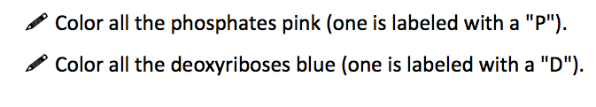

The rungs of the ladder are pairs of 4 types of nitrogen bases. Two of the bases are purines- **adenine** and **guanine**. The pyrimidines are **thymine** and **cytosine**. The bases are known by their coded letters **A, G, T, C**. These bases always bond in a certain way. **Adenine will only bond to thymine**. **Guanine will only bond with cytosine**. This is known as the "**Base-Pair Rule**". The bases can occur in any order along a strand of DNA. The order of these bases is the code that contains the instructions. For instance ATGCACATA would code for a different gene than AATTACGGA. A strand of DNA contains millions of bases. (For simplicity, the image only contains a few.)

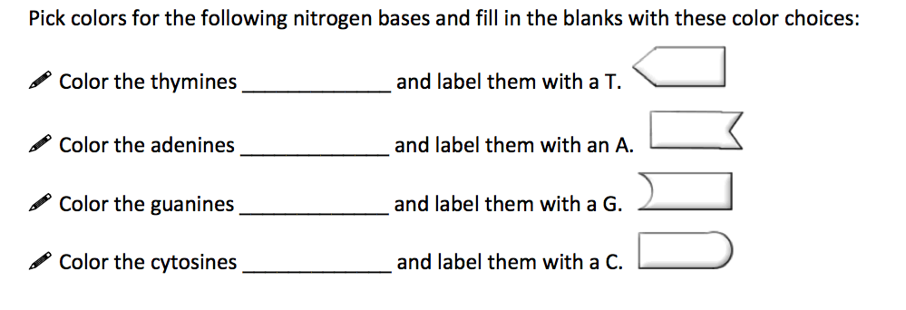

Note that that the bases attach to the sides of the ladder at the sugars and not the phosphate.

The DNA helix is actually made of repeating units called nucleotides. The combination of a **single base, a deoxyribose sugar, and a phosphate make up a nucleotide.** Color the nucleotides in the box using the same colors you used for the double helix.

The two sides of the DNA ladder are held together loosely by hydrogen bonds (see the small dots down the middle of the double helix). The DNA can actually "unzip" when it needs to replicate - or make a copy of itself. DNA needs to copy itself when a cell divides, so that the new cells each contain a copy of the DNA. Without these instructions, the new cells wouldn't have the correct information. The hydrogen bonds are

**Color the hydrogen bonds gray.**

**The Blueprint of Life**

Every cell in your body has the same "blueprint" or the same DNA. Like the blueprints of a house tell the builders how to construct a house, the DNA "blueprint" tells the cell how to build the organism. Yet, how can a heart be so different from a brain if all the cells contain the same instructions? Although much work remains in genetics, it has become apparent that a cell has the ability to turn off most genes and only work with the genes necessary to do a job. We also know that a lot of DNA apparently is nonsense and codes for nothing. These regions of DNA that do not code for proteins are called "introns", or sometimes "junk DNA". The sections of DNA that do actually code from proteins are called "exons".

**The DNA Double Helix**

**(Color according to the instructions)**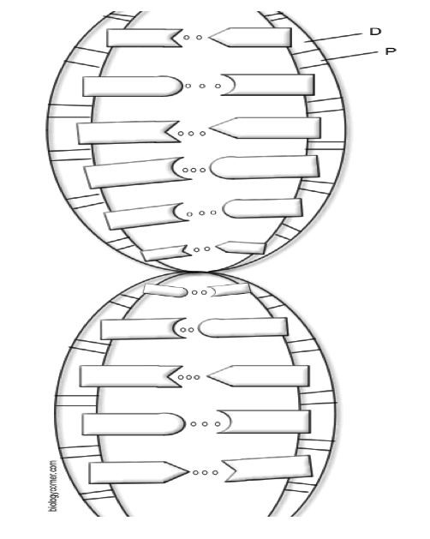

**Questions:**

1. Write out the full name for DNA.
2. Why is the nucleus called the “control center” of the cell?
3. Where in the cell are the chromosomes located?
4. What is a gene?
5. What do proteins do for your body?
6. What two scientists established the structure of DNA?
7. What are the sides of the DNA ladder made of?
8. What three parts make up a single nucleotide?
9. What are the 4 bases that make up the rungs of the DNA ladder?
10. What sugar is found in DNA?
11. How do the bases bond together in DNA?
12. What is the shape of DNA?
13. Why is DNA called the “Blueprint of Life”?
14. What holds the sides of the DNA ladder together?

***8.4- Model Deployment- DNA Classroom Model: Anti-Parallel Activity (Part-1)***

**Apparatus:**

Teacher will need pre-cut pieces provided in additional document.

**Pre-Activity Discussion:**

Students will quickly whiteboard the parts that make up DNA. Teacher will make sure to prompt them to label and list how things go together. Teacher is going to introduce the structures of deoxyribose and how it really creates the backbone after the whiteboards.

**Activity Performance Notes:**

Dependent on the size of your classroom, and your ability to pull from another class (such as a study hall), the size of your overall DNA model will vary.

Teacher should have a big model of what the deoxyribose looks like in the backbone showing the connection points of the phosphate and nitrogenous bases. (There is a template at the bottom of this document)

Ask for a volunteer and have them be the original model for the first deoxyribose. You will start identifying the students head as the O (Oxygen) and then start numbering their Carbons, left shoulder is C-1, left hip is C-2, right hip is C-3, right shoulder is C-4, and right wrist is C-5. (Note: Have the students tell you how to number the student.) You then ask the students if anything is missing, they should identify the phosphate and nitrogenous base. The phosphate is held in their right hand and the base is held in their left hand. (There is a picture at the end of the document.)

After the student is “decorated” with their parts the teacher then asks if all of the carbons are involved in connecting the pieces together. This will lead them to the idea that C-5 and C-3 are the carbons that attach the backbone and C-1 is where the bases connect. (This prevents you from having the have students label all 5 carbons and focusing only on the ones that make up the backbone.)

Now you start putting more and more students into the chain. The next student will attach their phosphate to the left hip (C-3) of the person in front, and so forth until you have half of your class in the chain. (Again dependent on your class size your line number will vary). (Note make sure that the remaining half will pair with your created strand).

Continue creating more nucleotides with the remaining students until they all have a nitrogenous base in their left hand. Then the teacher prompts them with which bases will pair with each other and the students will come up with what needs to attach to the first person. Now the teacher will say for the student to hydrogen bond to the first person in the chain. This is where you will have to watch to make sure they do not switch hands with their phosphate and base so that they are facing the same direction. The key is the connection made when they realize they have to face the opposite direction to pair with the other strand.

Once you have them build you can introduce the idea of DNA polymerase and you go through and connect the backbone of the new strand making them into a complete molecule of DNA. Once you have a completed molecule go to one end and ask them what part is sticking out on one strand, and then compare it to the other. This will show them that one has its 5’-C out and the other strand has its 3’-C out. Teacher then introduces the term Anti-parallel and how when one strand runs 5’-3’ while the other runs 3’-5’.

**Post-Activity Discussion:**

As a group pose the question “Why does DNA have to pair Anti-parallel?”. Also use this as a point to reemphasize the new terminology and structures they were exposed to.

They will be exposed to the following essential vocabulary:

* Anti-parallel
* 3’, 5’

Diagram: The solid black lines show the covalent bonds formed within the deoxyribose as well as between C-5 and P and C-1 and the bases. The lines going up to the head show the covalent bonds between C-4 and O and C-1 and O.

C-1

C-4

C-3

C-2

C-5

A,C,T,G

P

C-4

C-3

C-2

C-1

C-5

Deoxyribose

P

BASE

**Zipper Demo: Extension:**

**Instructional Notes:**

**Zipper Demo**

**Pre-activity Discussion**

Questions to be discussed (may be done using whiteboards)

What is the outcome of replication?

What happens during replication?

Draw a color picture of what DNA looks like prior to replication and following replication.

**Activity Performance Notes**

Utilizes 2 zippers of different colors.

1. Start with 1 zipper. This is the original strand of DNA.
2. Slowly unzip the zipper. Discuss how and why the zipper unzips.
3. Discuss how free DNA nucleotides are added to the unzipped DNA.
4. Using the other zipper (already unzipped) add one side of the “new DNA” (other colored zipper) to the original strand of DNA.
5. Repeat this process for the other strand of DNA.

**Post-activity Discussion**

Discuss the results of the newly formed DNA strands, highlighting that each strand now has an “old” strand and a “new” strand.

What advantage is there to having a piece of the “old” strand and a piece of the “new” strand?

Example of end result of DNA model

***8.4: DNA Replication Worksheet***

NAME: \_\_\_\_\_\_\_\_\_\_\_\_\_\_\_\_\_\_\_\_\_\_\_ DATE:\_\_\_\_\_\_\_\_\_\_\_\_ HOUR:\_\_\_\_\_\_\_\_\_\_\_\_

**DNA - The Double Helix - Visiting Replication**

**DNA Replication**

Each time a new cell is made, the cell must receive an exact copy of the parent cell DNA. The new cells then receive the instructions and information needed to function. The process of copying DNA is called replication. Replication occurs in a unique way- instead of copying a complete new strand of DNA, the process “saves” or conserves one of the original strand. When the DNA is ready to copy, the molecule “unzips” itself and new nucleotides are added to each side.

Image_7Color thereplication model. Notice that several **nucleotides** are floating around; they are waiting to pair up with their match. Use the same colors you used when coloring your DNA double helix.

The boxed section at the bottom shows two new strands of DNA. Color the old strands (including their half of the nitrogen bases, or “ladder rungs”) *red* and the new strand (including their half of the nitrogen bases) *green.*

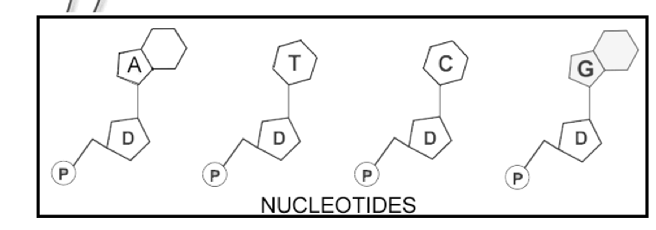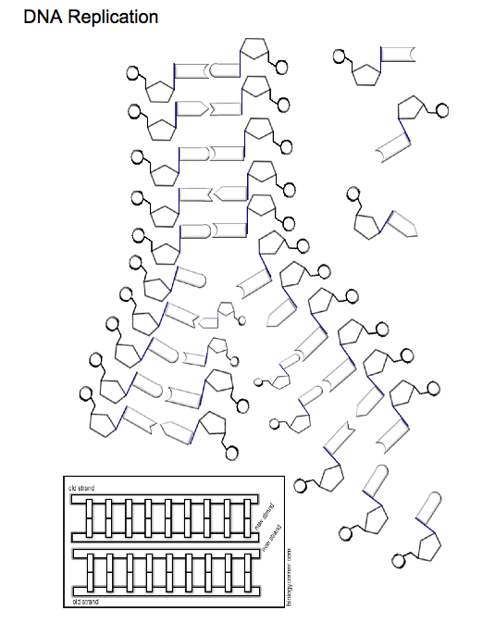**Questions:**

1. What is the process of copying DNA called?
2. Identify two important enzymes involved in replication.
3. Where does replication occur in the cell?
4. What is the product of replication?
5. Why is replication important to the cell and living organism?

***Day 5: Instructional Notes: Anti-Parallel Activity (Part-II, Replication)***

**Apparatus:**

Teacher will need anti-parallel activity pieces with DNA polymerase and DNA helicase.

**Pre-Activity Discussion:**

Teacher will have a class discussion having the students pull out the concepts behind DNA replication that they learned about during the Puzzle Pieces Lab Part II. This will be a segway into the use of the anti-parallel activity to let them act out replication.

**Activity Performance Notes:**

Have the students set up the activity like they did during the class period before. You can either select a student to be the helicase and the polymerase, or you can be that part of the activity.

Note: You are doing replication during this version of the activity so do not forget to leave some students out of the original model so that you have the ability to complete replication.

Before having the students start acting out replication have the other students become nucleotides so that they are replicating the concept that the nucleotides are in the surroundings. Once you are ready to start the DNA Helicase can come in and cut the hydrogen-bonds and then the DNA Polymerase can lock in the new bases. The only differences in set up are the introduction of the DNA polymerase and DNA Helicase to demonstrate how the pieces all come together.

**Post-Activity Discussion:**

Do a group discussion at the end of the activity having the students talk about how the enzymes and DNA pieces all work together to create the daughter strands from the parent strands.

***Day 6: Instructional Notes: Student Quiz***

**DNA Quiz**

**Multiple Choice (1pt each)**

**Directions:** Read each question carefully and select the answer you feel best fits. Record your answer in the space provided.

1. The nitrogenous base Adenine can pair with \_\_\_\_\_.

a. Adenine b. Cytosine c. Guanine d. Thymine

2. DNA strands run \_\_\_\_\_ in relation to each other.

a. antiparallel b. parallel c. perpendicular d. both a and b

3. A nucleotide in DNA is composed of \_\_\_\_\_.

a. a deoxyribose sugar, a phosphate, and a nitrogen base

b. only a deoxyribose sugar and a nitrogen base

c. only a deoxyribose sugar and a phosphate

d. none of the above

4. Between the two strands of a DNA segment the nitrogen bases are held together by

\_\_\_\_\_.

a. covalent bonds b. hydrogen bonds c. ionic bonds d. metallic bonds

5. Nitrogen bases pair with bases that are \_\_\_\_\_.

a. available b. complimentary c. identical d. both b and c

**Matching (1pt each)**

**Directions:** Write the letter for the answer or phrase in the space provided for each question.

1. DNA polymerase
2. deoxyribose
3. DNA replication
4. cytosine
5. DNA helicase
6. replication fork
7. nitrogen base
8. adenine
9. DNA
10. nucleotides

a. subunits that make up DNA one of the two pyrimidines

b. process of making a copy of DNA

c. makes up part of a nucleotide and is

d. made up of one or two rings of carbon

e. one of the two purines

f. abbreviation for deoxyribonucleic acid enzyme that opens up the double helix

g. by breaking hydrogen bonds

h. enzyme that adds nucleotides to a

i. nitrogen base according to the base- pairing rules.

j. two areas formed when the double helix separates during DNA replication.

h. a five-carbon sugar

**Short Answer:**

**Directions:** Answer each question in the space provided. To receive full credit you must answer in complete sentences.

16. Create the complimentary strand for the DNA strand below. Make sure to label the

parts and direction of the strand.

5'- A A C G G T C C A G T C C A A G T T A C G-3'

17. Below is a segment of DNA that is ready to be replicated. Show the processes that the

segment will go through during replication. Make sure to include the names of the enzymes that are involved.

AATTGCCTGCTAGTCTCAG TTAACGGACGATCAGAGTC

***Day 6/7: Instructional Notes: Paradigm II***

**Unit 3, Part 2 Lab: Airmail**

**Pre-lab discussion:**

1. What things do we have that enable use to communicate today? (Make a list of at least 10 ways)
2. Write down how you think DNA gets the information out to the rest of the cell so that the cell can function.
3. From what you know about the cell already, draw what parts of the cell that are involved in DNA communication.

* In this classroom simulation, we will observe how DNA communicates and how its instructions are copied and translated into a useable language that the cell can understand.

**Apparatus:**

* Assorted blocks/ legos, etc (5-10)\*
* Cell phones that are texting enabled (2 per group)
* Computers
* Ipad or Ipod touch
* Paper
* Writing Materials
* Area marked “nucleus” (one end of the room)
* Area marked “ribosome” (at other end of the room)

\*Blocks must match for each group. For example nucleus and ribosome both have same blocks for same group.

**Procedure (teacher):**

1. Students will be placed in teams of 4 to 5 individuals. Two students will go to one side of the room and the other 2 to 3 individuals will go to the opposite end of the room.
2. Each group of students will have the same “building blocks” at each end of the room. Students will be told that they are the cell and one group in the DNA in the nucleus while the other group is at the ribosome awaiting to assemble the protein. The nucleus is full of nucleotides, the building blocks of DNA, while the ribosome is full of amino acids, the building blocks of proteins.
3. The students on the DNA side will be asked to construct the information they are going to send by building a structure using the blocks.
4. After the DNA constructs it, they need to write down instructions in paragraph form to tell how to put it together.
5. They will then need to cut out the pieces that are not important before it is ready to be sent. They will act as splicesomes and condense their message they wrote down into under 25 text words total. \*\*You can adjust the amount of text words your students will use depending on your class. You may also try this more than once and have groups switch places and challenge them to use only 15-20 words.
6. When they finish they will send their condensed message out of the nucleus to the ribosome where the message will be translated and put back together and made into a protein using the amino acids.
7. Throughout scenario groups should record observations about how the process worked and what they noticed about the process they are completing.

Process observations:

|  |  |
| --- | --- |
| At Nucleus | At Ribosome |
|  |  |

**Post-lab discussion:**

1. Rewrite in your own words how the DNA communicates to the rest of the cell to get its message out to make a protein.
2. Draw a new picture to show the parts of the cell that are involved in this process.

***Day 8: Instructional Notes:***

***Day 9: How to Read a Codon Chart/ Codon Bingo***

**Adapted from Cynthia Mannix:** 1994 Woodrow Wilson Biology Institute

## Introduction

Codon Bingo is a stimulating game that involves deciphering the genetic code. It is a game designed for students to practice transcription and translation of codons. It has the advantage that it is a game that students enjoy while they actively participate. All students become engaged in this activity as it generates a lot of enthusiasm. As they play the game, they develop increased proficiency at unraveling the genetic code found in the base pairs. After playing this game, the task of transcribing the DNA base pair messages into mRNA codons and then translating the mRNA codons into amino acids becomes much easier.

The following is a brief summary. The students are given a bingo card with blank spaces. They choose where all twenty amino acids will be placed and write the amino acid names on the bingo card. As the names of DNA triplets are called, they transcribe the DNA into a mRNA codon and then into its respective amino acid. If the codon for an amino acid they have on their card is called, they place a marker on the appropriate spot. Once the students have five markers placed across, down or diagonally, they win! The students read back their amino acids, which has become a polypeptide of four or five amino acids, while the teacher checks for accuracy. The students get immediate feedback on their ability to decode DNA.

Thus while playing a lively game they get repeated practice decoding the genetic message in a fun, dynamic way with their peers. They gain a facility with the mechanism of gene translation that makes further investigations much easier. The code in the DNA molecule becomes tangible and comprehensible.

## Target Age/Ability Group:

This game is designed for introductory high school biology students who have had an introduction to DNA structure, transcription, and translation.

## Teacher Information

**Preparation**

* Copy 1 blank bingo card for each student or team (included). If they wish to make different cards and you are amenable to that you will need more than one card per student.
* Copy a set of the "codon game cards" (included).
* Cut these "codon game cards" into individual squares and place in a bingo basket for drawing .
* Decide if students will play alone or in paired teams.

**Instructions for Playing Codon Bingo**

1. Provide each student or team with the following:
   * 1 bingo card
   * several markers (pennies work well)
   * 1 codon chart with RNA codons and their respective amino acids (found in texts)
   * 1 list of the twenty amino acids (found in texts)
   * colored pencils
2. Direct the team or individual to write the name of all 20 amino acids on their cards. They may choose where they wish to position them. They will have some amino acids on their cards twice as there are 24 empty spaces to fill.
3. Once the bingo cards are ready, draw 1 "codon game card" from the basket and read the DNA triplet code to the class.{Please note: on the "codon game cards" the small 'D' is the DNA triplet (sense strand) and the small 'R' is the mRNA codon.} They must then transcribe the DNA base pair triplet into the RNA transcript. Then using a codon chart, they translate the mRNA codon into an amino acid. If they have that amino acid on their card somewhere they may place a marker on that space.
4. Discard the used "codon game card" by laying it to one side. You will need it for the checking process. Give the students enough time before drawing the next card - especially in the beginning of the game.
5. Continue drawing and reading cards until someone yells "Bingo!" At this point check his or her decoding by having the student read the four or five marked amino acids. Point out that this is now a polypeptide. While the student reads out the amino acids, check for accuracy in the discard pile. If a student has made a mistake and marked an inappropriate amino acid, he or she is out of the game for this round.
6. Reward the winner(s) in some way to enhance motivation. Play the next round.
7. **Variation #1:** When preparing the cards, allow the students to choose as many or as few of the amino acids as they like and position them on the bingo cards. {Note: It might be wise to restrict them from using fewer than two or three amino acids.}
8. **Variation #2:** The pace of the game can be slow or fast depending on the student population. After a few rounds of practice, picking up the pace can add a new challenge.
9. **Variation #3:** Instead of calling out the DNA triplet code on the "codon game card" call out the RNA codon and have them only translate into an amino acid. This is an easier variation and might be a way you would want to begin the first few rounds of the game for beginners.
10. The teacher and students can create all sorts of variations and rules to add interest.

## CODON BINGO

|  |  |  |  |  |
| --- | --- | --- | --- | --- |
|  |  |  |  |  |
|  |  |  |  |  |
|  |  | FREESPACE |  |  |
|  |  |  |  |  |
|  |  |  |  |  |

[https://www.google.com/search?q=codon+charts&hl=en&client=firefox-a&hs=c13&rls=org.mozilla:en-US:official&prmd=imvns&tbm=isch&tbo=u&source=univ&sa=X&ei=6wUQUJ72I-7M6QG-loGwAg&ved=0CFAQsAQ&biw=1238&bih=589#](https://www.google.com/search?q=codon+charts&hl=en&client=firefox-a&hs=c13&rls=org.mozilla:en-US:official&prmd=imvns&tbm=isch&tbo=u&source=univ&sa=X&ei=6wUQUJ72I-7M6QG-loGwAg&ved=0CFAQsAQ&biw=1238&bih=589)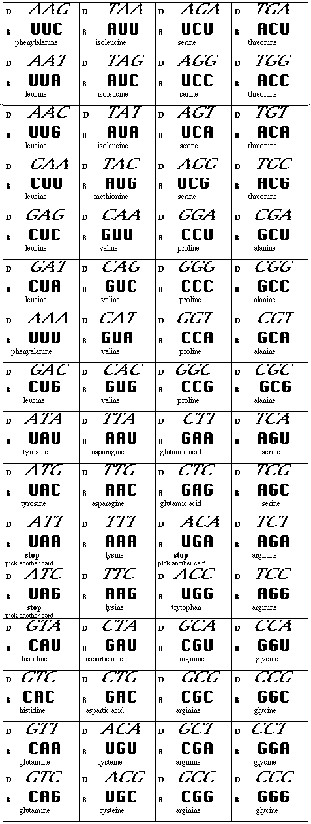

Examples of Codon Charts students can use:

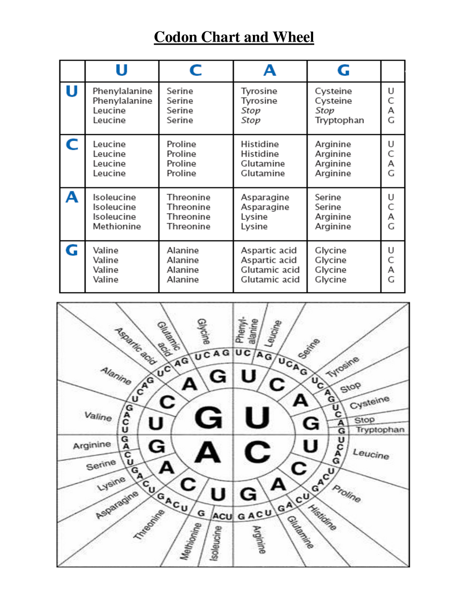

***Day 10: Instructional Notes-***  ***CHNOPS Lab***

Objectives:

Before doing this assignment the student should be able to:

- define gene

- state where in the cell transcription and translation take place

- describe the structure and function of DNA and RNA in inheritance

After doing this assignment the student should be able to:

- distinguish between transcription and translation

- describe the role of mRNA and tRNA in gene expression

- model gene expression from transcription to the level of phenotype (trait)

- relate genes and alleles to genotypes and phenotypes

In this investigation, students will simulate the mechanism of protein synthesis and thereby determine the traits inherited by fictitious organisms called CHNOPs (represents carbon, hydrogen, nitrogen, oxygen, and phosphorousThese organisms contain only one chromosome and are members of the Kingdom Animalia. A CHNOPS’ chromosome is made up of six genes (A, B, C, D, E, and F), each of which is responsible for a certain trait. Students will need to have colored pencils (blue and orange) and drawing paper provided. The finished drawings can be placed at the front of the room to compare traits.

The student worksheets provided vary in all traits but two - hairy and long nose. Are those traits more important to survival of the species? (Example of one of the worksheets are located below)

CHNOPS Lab

Constructing a Model of Protein Synthesis

Name \_\_\_\_\_\_\_\_\_\_\_\_\_\_\_\_\_\_\_\_\_\_\_\_\_\_\_\_\_\_\_\_\_\_\_\_\_\_ Date \_\_\_\_\_\_\_\_\_\_\_\_\_\_\_ Hour \_\_\_\_\_\_\_\_\_

**PRE-LAB DISCUSSION**

Genes are the units that determine inherited characteristics, such as hair color and blood type. Genes are lengths of DNA molecules that determine the structure of polypeptides (the building blocks of proteins) that our cells make. The sequence of nucleotides in DNA determines the sequence of amino acids in polypeptides, and thus the structure of proteins.

In a process called *transcription*, which takes place in the nucleus of the cell, messenger RNA (mRNA) reads and copies the DNA’s nucleotide sequences in the form of a complementary RNA molecule. Then the mRNA carries this information in the form of a code to the ribosomes, where protein synthesis takes place. The code, in DNA or mRNA, specifies the order in which the amino acids are joined together to form a polypeptide. The code words in mRNA, however, are not directly recognized by the corresponding amino acids. Another type of RNA called transfer RNA (tRNA) is needed to bring the mRNA and amino acids together. As the code carried by mRNA is “read” on a ribosome, the proper tRNAs arrive in turn and give up the amino acids they carry to the growing polypeptide chain. The process by which the information from DNA is transferred into the language of proteins is known as *translation*.

In this investigation, you will simulate the mechanism of protein synthesis and thereby determine the traits inherited by fictitious organisms called CHNOPS. CHNOPS, whose cells contain only one chromosome, are members of the kingdom Animalia. A CHNOPS chromosome is made up of eight genes (A, B, C, D, E, F, G and H), each of which is responsible for a certain trait.

**PROCEDURE**

1. To determine the trait for Gene A of your CHNOPS, first you must transcribe the DNA into mRNA.
2. Then, you must write the nucleotides of tRNA that are complementary to mRNA.
3. Use the chart in Figure 1 to find the corresponding amino acid sequence. Remember to use the mRNA sequence and not the tRNA sequence in this chart!
4. Using figure 2, find the trait that matches the amino acid sequence. To save space, you may abbreviate each amino acid. Record this information in the appropriate place.
5. Repeat steps 1 through 4 for the remaining genes (B through F).
6. Create DNA for the final two traits (Gene G and Gene H) and give their initial DNA sequence, mRNA codon, tRNA anticodon, and the amino acid sequence. Start with the trait listed and work backwards to fill in the information for Genes G and H.
7. Using all the inherited traits, sketch your CHNOPS in the space provided.

**Figure 1**

|  |  |  |  |  |  |
| --- | --- | --- | --- | --- | --- |
| ***First***  ***Base*** | ***Second Base*** |  |  |  | ***Third***  ***Base*** |
|  | **U** | **C** | **A** | **G** |  |
| **U** | Phenylalanine | Serine | Tyrosine | Cysteine | **U** |
|  | Phenylalanine | Serine | Tyrosine | Cysteine | **C** |
|  | Leucine | Serine | Stop | Stop | **A** |
|  | Leucine | Serine | Stop | Tryptophan | **G** |
| **C** | Leucine | Proline | Histidine | Arginine | **U** |
|  | Leucine | Proline | Histidine | Arginine | **C** |
|  | Leucine | Proline | Glutamine | Arginine | **A** |
|  | Leucine | Proline | Glutamine | Arginine | **G** |
| **A** | Isoleucine | Threonine | Asparagine | Serine | **U** |
|  | Isoleucine | Threonine | Asparagine | Serine | **C** |
|  | Isoleucine | Threonine | Lysine | Arginine | **A** |
|  | Methionine (start) | Threonine | Lysine | Arginine | **G** |
| **G** | Valine | Alanine | Aspartate | Glycine | **U** |
|  | Valine | Alanine | Aspartate | Glycine | **C** |
|  | Valine | Alanine | Glutamate | Glycine | **A** |
|  | Valine | Alanine | Glutamate | Glycine | **G** |

**Figure 2**

|  |  |
| --- | --- |
| **Amino Acid Sequence** | **Trait** |
| Tyrosine – Alanine – Tyrosine | Hairless |
| Lysine – Leucine | Hairy |
| Proline – Alanine – Alanine | Plump |
| Histidine – Arginine | Skinny |
| Tryptophan – Proline – Isoleucine | Four-legged |
| Threonine – Serine – Serine | Two-legged |
| Tyrosine – Glutamate - Aspartate | Long nose |
| Lysine – Arginine – Serine – Leucine | Short nose |
| Valine – Isoleucine | No freckles |
| Serine – Alanine | Freckles |
| Proline – Serine – Phenylalanine - Glycine | Blue skin |
| Proline – Serine – Glycine | Orange skin |
| Methionine – Tryptophan – Stop | Short legs |
| Cysteine – Methionine – Alanine | Long legs |
| Methionine – Phenylalanine – Valine | Long tail |
| Valine – Glycine – Cysteine | Short tail |
| Asparagine – Threonine – Methionine | Spots |
| Cysteine – Aspartate - Stop | Stripes |

|  |  |  |
| --- | --- | --- |
| **Gene A** | **Gene B** | **Gene C** |
| **DNA** A C C G G T T A T | **DNA** A G C C G A | **DNA** T T T A A C |
| **mRNA** \_\_\_\_\_\_\_\_\_\_\_\_\_\_\_\_\_\_\_\_\_ | **mRNA** \_\_\_\_\_\_\_\_\_\_\_\_\_\_\_\_\_\_\_\_\_ | **mRNA** \_\_\_\_\_\_\_\_\_\_\_\_\_\_\_\_\_\_\_\_\_ |
|  |  |  |
| **Amino Acid**  **Sequence** \_\_\_\_\_\_\_\_\_\_\_\_\_\_\_\_\_\_\_  **tRNA** \_\_\_\_\_\_\_\_\_\_\_\_\_\_\_\_\_\_\_\_\_ | **Amino Acid**  **Sequence** \_\_\_\_\_\_\_\_\_\_\_\_\_\_\_\_\_\_\_  **tRNA \_\_\_\_\_\_\_\_\_\_\_\_\_\_\_\_\_\_\_\_\_\_** | **Amino Acid**  **Sequence** \_\_\_\_\_\_\_\_\_\_\_\_\_\_\_\_\_\_\_  **tRNA \_\_\_\_\_\_\_\_\_\_\_\_\_\_\_\_\_\_\_\_\_\_** |
| **Trait** \_\_\_\_\_\_\_\_\_\_\_\_\_\_\_\_\_\_\_\_\_\_ | **Trait** \_\_\_\_\_\_\_\_\_\_\_\_\_\_\_\_\_\_\_\_\_\_ | **Trait** \_\_\_\_\_\_\_\_\_\_\_\_\_\_\_\_\_\_\_\_\_\_ |
| **Gene D** | **Gene E** | **Gene F** |
| **DNA** G T G T C T | **DNA** G G G A G T C C C | **DNA** A T G C T C C T A |
| **mRNA** \_\_\_\_\_\_\_\_\_\_\_\_\_\_\_\_\_\_\_\_\_ | **mRNA** \_\_\_\_\_\_\_\_\_\_\_\_\_\_\_\_\_\_\_\_\_ | **mRNA** \_\_\_\_\_\_\_\_\_\_\_\_\_\_\_\_\_\_\_\_\_ |
|  |  |  |
| **Amino Acid**  **Sequence** \_\_\_\_\_\_\_\_\_\_\_\_\_\_\_\_\_\_\_  **tRNA \_\_\_\_\_\_\_\_\_\_\_\_\_\_\_\_\_\_\_\_\_\_** | **Amino Acid**  **Sequence** \_\_\_\_\_\_\_\_\_\_\_\_\_\_\_\_\_\_\_  **tRNA \_\_\_\_\_\_\_\_\_\_\_\_\_\_\_\_\_\_\_\_\_\_** | **Amino Acid**  **Sequence** \_\_\_\_\_\_\_\_\_\_\_\_\_\_\_\_\_\_\_  **tRNA \_\_\_\_\_\_\_\_\_\_\_\_\_\_\_\_\_\_\_\_\_\_** |
| **Trait** \_\_\_\_\_\_\_\_\_\_\_\_\_\_\_\_\_\_\_\_\_\_ | **Trait** \_\_\_\_\_\_\_\_\_\_\_\_\_\_\_\_\_\_\_\_\_\_ | **Trait** \_\_\_\_\_\_\_\_\_\_\_\_\_\_\_\_\_\_\_\_\_\_ |
| **Gene G** | **Gene H** |  |
| **DNA** | **DNA** |  |
| **mRNA** \_\_\_\_\_\_\_\_\_\_\_\_\_\_\_\_\_\_\_\_\_ | **mRNA** \_\_\_\_\_\_\_\_\_\_\_\_\_\_\_\_\_\_\_\_\_ |  |
|  |  |  |
| **Amino Acid**  **Sequence** \_\_\_\_\_\_\_\_\_\_\_\_\_\_\_\_\_\_\_  **tRNA \_\_\_\_\_\_\_\_\_\_\_\_\_\_\_\_\_\_\_\_\_\_** | **Amino Acid**  **Sequence** \_\_\_\_\_\_\_\_\_\_\_\_\_\_\_\_\_\_\_  **tRNA \_\_\_\_\_\_\_\_\_\_\_\_\_\_\_\_\_\_\_\_\_\_** |  |
| **Trait** \_stripes\_\_\_\_\_\_\_\_\_\_\_\_\_\_\_\_ | **Trait** \_long tail\_\_\_\_\_\_\_\_\_\_\_\_\_\_ |  |

\*\* Draw your CHNOPS on paper provided.

**ANALYZE AND CONCLUDE**

1. Explain the differences between translation and transcription. \_\_\_\_\_\_\_\_\_\_\_\_\_\_\_\_\_\_\_\_\_\_\_\_\_\_\_\_\_\_\_\_\_

\_\_\_\_\_\_\_\_\_\_\_\_\_\_\_\_\_\_\_\_\_\_\_\_\_\_\_\_\_\_\_\_\_\_\_\_\_\_\_\_\_\_\_\_\_\_\_\_\_\_\_\_\_\_\_\_\_\_\_\_\_\_\_\_\_\_\_\_\_\_\_\_\_\_\_\_\_\_\_\_\_\_

\_\_\_\_\_\_\_\_\_\_\_\_\_\_\_\_\_\_\_\_\_\_\_\_\_\_\_\_\_\_\_\_\_\_\_\_\_\_\_\_\_\_\_\_\_\_\_\_\_\_\_\_\_\_\_\_\_\_\_\_\_\_\_\_\_\_\_\_\_\_\_\_\_\_\_\_\_\_\_\_\_\_

\_\_\_\_\_\_\_\_\_\_\_\_\_\_\_\_\_\_\_\_\_\_\_\_\_\_\_\_\_\_\_\_\_\_\_\_\_\_\_\_\_\_\_\_\_\_\_\_\_\_\_\_\_\_\_\_\_\_\_\_\_\_\_\_\_\_\_\_\_\_\_\_\_\_\_\_\_\_\_\_\_\_

\_\_\_\_\_\_\_\_\_\_\_\_\_\_\_\_\_\_\_\_\_\_\_\_\_\_\_\_\_\_\_\_\_\_\_\_\_\_\_\_\_\_\_\_\_\_\_\_\_\_\_\_\_\_\_\_\_\_\_\_\_\_\_\_\_\_\_\_\_\_\_\_\_\_\_\_\_\_\_\_\_\_

1. What is the specific site for transcription in the cell? \_\_\_\_\_\_\_\_\_\_\_\_\_\_\_\_\_\_\_\_\_\_\_\_\_\_\_\_\_
2. What is the specific site for translation in the cell? \_\_\_\_\_\_\_\_\_\_\_\_\_\_\_\_\_\_\_\_\_\_\_\_\_\_\_\_\_\_\_
3. How many tRNA nucleotides form an anticodon that will attach to the mRNA codon? \_\_\_\_\_\_\_\_\_\_\_\_
4. Suppose you knew the makeup of specific proteins in a cell. How could you determine the particular DNA code that coded for them? (Think about it, you did this in this lab.)

\_\_\_\_\_\_\_\_\_\_\_\_\_\_\_\_\_\_\_\_\_\_\_\_\_\_\_\_\_\_\_\_\_\_\_\_\_\_\_\_\_\_\_\_\_\_\_\_\_\_\_\_\_\_\_\_\_\_\_\_\_\_\_\_\_\_\_\_\_\_\_\_\_\_\_\_\_\_\_\_\_\_

\_\_\_\_\_\_\_\_\_\_\_\_\_\_\_\_\_\_\_\_\_\_\_\_\_\_\_\_\_\_\_\_\_\_\_\_\_\_\_\_\_\_\_\_\_\_\_\_\_\_\_\_\_\_\_\_\_\_\_\_\_\_\_\_\_\_\_\_\_\_\_\_\_\_\_\_\_\_\_\_\_\_

\_\_\_\_\_\_\_\_\_\_\_\_\_\_\_\_\_\_\_\_\_\_\_\_\_\_\_\_\_\_\_\_\_\_\_\_\_\_\_\_\_\_\_\_\_\_\_\_\_\_\_\_\_\_\_\_\_\_\_\_\_\_\_\_\_\_\_\_\_\_\_\_\_\_\_\_\_\_\_\_\_\_

\_\_\_\_\_\_\_\_\_\_\_\_\_\_\_\_\_\_\_\_\_\_\_\_\_\_\_\_\_\_\_\_\_\_\_\_\_\_\_\_\_\_\_\_\_\_\_\_\_\_\_\_\_\_\_\_\_\_\_\_\_\_\_\_\_\_\_\_\_\_\_\_\_\_\_\_\_\_\_\_\_\_

\_\_\_\_\_\_\_\_\_\_\_\_\_\_\_\_\_\_\_\_\_\_\_\_\_\_\_\_\_\_\_\_\_\_\_\_\_\_\_\_\_\_\_\_\_\_\_\_\_\_\_\_\_\_\_\_\_\_\_\_\_\_\_\_\_\_\_\_\_\_\_\_\_\_\_\_\_\_\_\_\_\_

1. How could one change in a DNA nucleotide alter the formation of the translated protein? For example, if we changed or removed the nucleotide in **bold** from the following DNA strand, how would that affect the formation of the protein? Explain (step by step).

DNA : T A C **T** C A A T T C A C G C T

\_\_\_\_\_\_\_\_\_\_\_\_\_\_\_\_\_\_\_\_\_\_\_\_\_\_\_\_\_\_\_\_\_\_\_\_\_\_\_\_\_\_\_\_\_\_\_\_\_\_\_\_\_\_\_\_\_\_\_\_\_\_\_\_\_\_\_\_\_\_\_\_\_\_\_\_\_\_\_\_\_\_

\_\_\_\_\_\_\_\_\_\_\_\_\_\_\_\_\_\_\_\_\_\_\_\_\_\_\_\_\_\_\_\_\_\_\_\_\_\_\_\_\_\_\_\_\_\_\_\_\_\_\_\_\_\_\_\_\_\_\_\_\_\_\_\_\_\_\_\_\_\_\_\_\_\_\_\_\_\_\_\_\_\_

\_\_\_\_\_\_\_\_\_\_\_\_\_\_\_\_\_\_\_\_\_\_\_\_\_\_\_\_\_\_\_\_\_\_\_\_\_\_\_\_\_\_\_\_\_\_\_\_\_\_\_\_\_\_\_\_\_\_\_\_\_\_\_\_\_\_\_\_\_\_\_\_\_\_\_\_\_\_\_\_\_\_

\_\_\_\_\_\_\_\_\_\_\_\_\_\_\_\_\_\_\_\_\_\_\_\_\_\_\_\_\_\_\_\_\_\_\_\_\_\_\_\_\_\_\_\_\_\_\_\_\_\_\_\_\_\_\_\_\_\_\_\_\_\_\_\_\_\_\_\_\_\_\_\_\_\_\_\_\_\_\_\_\_\_

***Day 11: Instructional Notes- Proteins Revisited***

**Pre-lab discussion:**

1. Name some proteins that you know of: (At least 3)
2. What role in the cell do you think each of these proteins play?
3. Looking at the cell below label where you find the DNA, the Proteins.

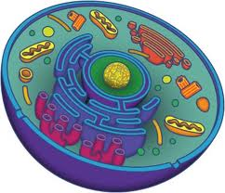

**Apparatus:**

* Cell model/Pictures
* Technology to research different proteins
* Paper
* Writing Materials
* Whiteboards/Materials

**Procedure (teacher):**

1. Students will be put into up to 9 groups and asked to research the following questions about proteins:
   1. Where is your protein manufactured and found?
   2. What does your particular protein do?
   3. When is your protein produced and when does the protein “work”?

When they are finished with the research, they should show their “results” on a whiteboard. They should include a description, a picture, and a concept map on the whiteboard that answers the three questions above.

Below is a table showing the different proteins that may be used for research classified by their biological function. If you cannot draw these proteins out in pre-discussion, you may give groups some ideas for the research.

|  |  |
| --- | --- |
| Type of Protein | Examples You Can Use |
| Enzymes | Helicase, DNA Polymerase, RNA Polymerase, Ligase, Amylase |
| Structural/Support | Keratin, Elastin, Collagen |
| Gas Transport | Hemoglobin |
| Nutritional Storage | Ovalbumin, Casein |
| Immune Response | Antibodies (Immunoglobulins- Four types: IgA, IgG, IgM, and IgE) |
| Hormones | Estrogen, Testosterone, Insulin, Dopamine, Serotonin |
| Mechanical Work | Actin, Myosin |
| Metabolic | Thyroxine |

**Post-lab discussion:**

1. What did you discover about proteins through your research and through other whiteboards?
2. How would you relabel your cell that you labeled at the beginning?
3. Thinking back to Protein Synthesis, why are proteins so vital to understand?
4. Why is it important that proteins are built correctly? What might result if something went wrong?