Gnus and You
A Dissertation
Submitted to the Graduate School
of the University of Notre Dame
in Partial Fulfillment of the Requirements
for the Degree of
Doctor of Philosophy
by
Gerald G. Gnastich
Gary Greenfield, Director
Graduate Program in Gnuology
Notre Dame, Indiana
April 2016

<NEXT PAGE SECTION BREAK: BEGIN COPYRIGHT>
© Copyright 2016
Gerald G. Gnastich

<NEXT PAGE SECTION BREAK: BEGIN ABSTRACT>
Gnus and You
Abstract
by
Gerald G. Gnastich
In this thesis, I will tell all that I know about Gnus. Gnus are wonderful little creatures that inhabit the center of the earth and give us wonderful and plentiful trees, dirt, and other earthly-things.
In short, we should love and cherish the Gnus. They can be very friendly, and are often mistaken for squirrels on the University of Notre Dame campus. Feed them whenever possible. If they get caught in trash cans, tip them over so that they can get out.
This abstract is going to continue on, including a few formulae, just for the sake of spilling over on to two pages so that we can see the author's name in the top right corner:
a2 + b2 = c2
E = mc2
e/m = c2
a2 + b2 = e/m
These equations, by themselves mean nothing. But to the common Gnu, they define a whole way of living. While intricate mathematical implications certainly do not infiltrate the majority of humans' lives, every Gnu, from birth, is imbued with a sense of mathematical certainty and guidance. All Gnus, great and small, feel at one with mathematics. The cute furry bit is just a scam for their calculating minds.
This dissertation will not address this subject at all, but I felt compelled to mention it here. Mainly so that we can spill over to two pages and see my name at the top of the second. Don't you think that Gnus are good things?

<NEXT PAGE SECTION BREAK: BEGIN ROMAN NUMERAL PAGE NUMBERS>
This is for George, my favorite Gnu.
Contents

Figures

Tables

Preface
I would like to preface this work with all the wonderful things that Gnus have brought to our society: trees, dirt, flowers, grass, lakes, and other earthly-things. We should not forget them in our daily lives.
Additionally, we should offer them food for all their hard work. In fact, Gnus work so hard that they sleep for the colder half of the year. As such, they tend to grow a little rotund. Humans should not fault them for this, as it is necessary for their survival. Indeed, many humans grow rotund on their own accord!

Acknowledgments
I would like to acknowledge all the loving Gnus at Notre Dame. Particularly the one that comes to the window in the Hayes Healy building. He (she?) has given me much inspiration, love, and dirt. I would also like to thank my advisor, Dr. Gary Greenfield, with whom this work would not have been possible.
Finally, I would like to thank the U.S. Government, Department of Gnus, for their generous grant, number GNU3042920920.3, which allowed me to pursue my work.

<NEXT PAGE SECTION BREAK: BEGIN MAIN TEXT CHAPTERS>
Chapter 1
Introduction
Overview
This is an overview of the introduction. In here, I will use many, many buzzwords and other legalistic-types of terms, mostly beginning on the expounding of the holistic and synergistic energy that Gnus bring to our organizations.
Background
In preparation for reading this dissertation, I would highly recommend reading some of the other material available on Gnus [3, 4]. They are very well written and will give you a fuller understanding of Gnus.
As shown in Figure 1.1, Gnus are frequently mistaken for squirrels. They are not squirrels. They are Gnus. Don’t call them squirrels, either (unless you have food in your hand); they tend to get a bit upset. If you have food in your hand, they tend to ignore this insult and accept your food as a peace offering.
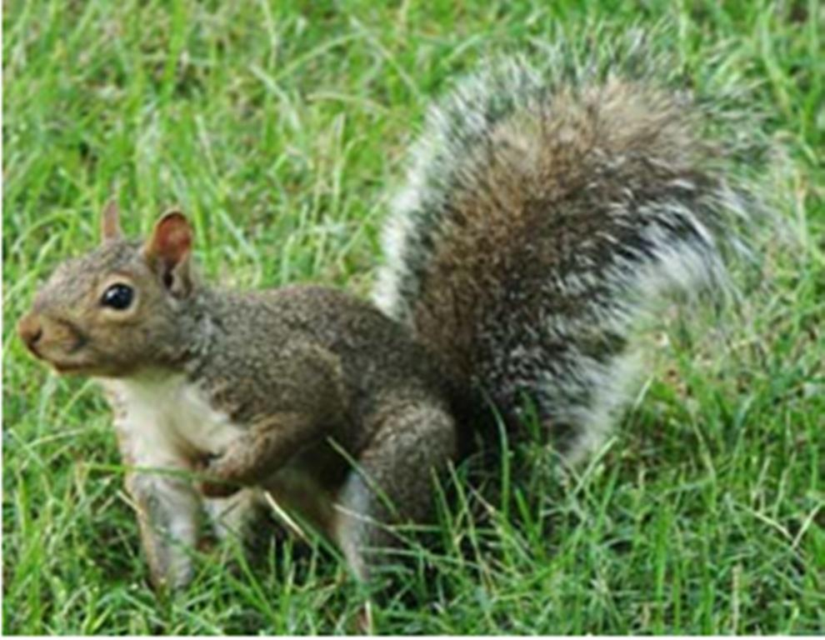
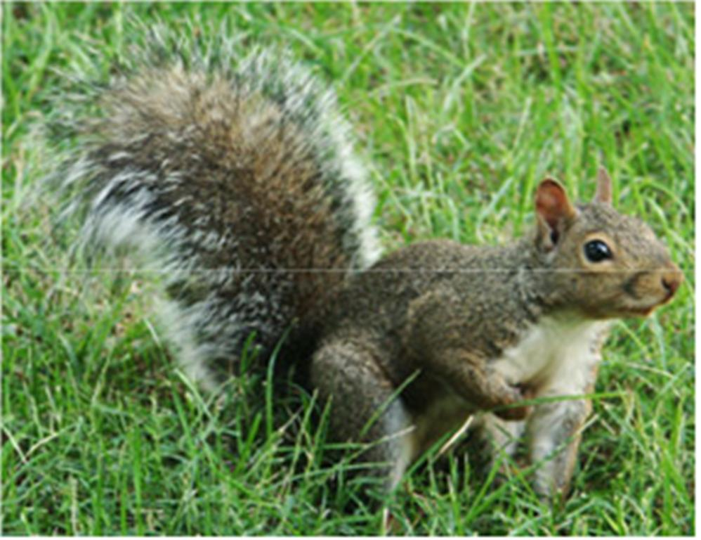
Beloved campus Gnu Glen checking the state of the lawn on the main quad. Contrast this image with the mugshot of a squirrel recently spotted prowling the grounds. Although a Gnu’s inherent furry cuteness makes it easy to mistake one for a squirrel, Gnus are much more polite and lack the beady eyes and suspicious demeanor of a squirrel.

Foreground
Table 1.1 shows some feeding frequencies for where Gnus like to eat around the Notre Dame campus. Gnus have work weeks, just like humans do, hence the much lower frequencies on weekends. This can lead us to conclude that Gnu weekend shifts are much smaller than the normal work-week shifts. In fact, we can attempt to parameterize the sighting frequency, F, by the student population, type of food, and day of the week as:
F = F(p, f, d) (1.1)
Table x.x
Where Gnus Like to Eat
Location | Sun | Mon | Tue | Wed | Thu | Fri | Sat
Front of Dome | 1 | 5 | 6 | 5 | 4 | 5 | 1
Stonehenge | 2 | 9 | 10 | 12 | 9 | 14 | 2
The Rock | 1 | 3 | 4 | 3 | 4 | 3 | 0
The ACC | 3 | 4 | 5 | 5 | 5 | 4 | 1
Dining Halls | 5 | 14 | 12 | 13 | 14 | 12 | 3
NOTE: Listed by average number of sightings on a weekday

Gnus typically tend to come out when there are large gatherings of humans with food. Gnus work very hard at providing us with all the things that we like (trees, dirt, air, etc.), and so we should freely give them food. They will come up and stand a respectful distance away from you, waiting to see if they will be rewarded for their efforts. If you offer some food, they will take it and back off a respectful distance in order to consume their food while leaving you to your “personal space.”
Groovin’ Gnus
Gnus do tend to stay away from humans in their normal day-to-day workings. This is mainly because humans don’t, for the most part, understand what they are doing. If a Gnu is working, and a human approaches it, the Gnu will tend to drop whatever it is doing and run away. This is probably due to the tendency for humans to have “group meetings” and “productivity seminars.” Most Gnus are deathly afraid of such over-management, and run at the slightest hint of it, for fear that it will cripple their real work.
It is interesting, however, that Gnus have chosen an Institution of Higher Education for their BoO. It is often said that:
Academic politics are the dirtiest, meanest, ugliest, and generally the most low-down, in-your-face, and kick-ʼem-while-they’re-down than anywhere else (even Washington D.C.) because the stakes are so low.
It has been hypothesized that the Gnus are subtly trying to affect a change for the better (i.e., eliminating the over-management problems) by working the very system that they are trying to change, from within. That is, the graduates from Notre Dame can learn from the examples of the Gnus here, and run screaming (or chattering) at the slightest hint of over-management, and let the real work proceed unhindered.

Chapter 2
Gnu Things Are Good Things for All Graduate Students
Gnu See, Gnu Do, Gnu Goes Golfing with Green Golf Genes and Gesticulates Grapes
So why do gnus do what they do? This is a perennial question that has yet to be answered definitively by scientists. Is their future somehow tied inexplicably with that of humans? Hard to say, but we do feed them a lot. It has even been theorized that rotundness is a symbol of status or class within the Gnus; those who are more productive (i.e., cute, furry, friendly) will be fed more than those who are less so. So the more rotund, the higher status one has in the Gnu society.
One could extrapolate this to mean that there is a super-Gnu out there somewhere; the biggest, rotundest Gnu that you’ve ever seen, probably of epic proportions! This would have to be the Leader of Gnus, or LoG for short. But the LoG would definitely have to be the cutest, furriest, and most friendly Gnu that you’ve ever seen.
The LoG
So how does the LoG get chosen? Ultimately, by humans. So we can say that the Gnu society is perhaps the truest democracy that has ever existed; the leader is chosen by merit, and chosen by complete outsiders. As such, the LoG must truly epitomize all that Gnus stand for: opposedness to over-management, cuteness, friendliness, and furriness [2]. The gnus themselves vote at an annual election, based upon these attributes.

Appendix A: Gnu Generalisms
Sightings
Table A.1 shows the most frequently sighted Gnus on campus. Observations recorded are current as of December 2015.
Table A.1
Frequently Encountered Gnus
Name | Sightings | M/F | Favorite Food | Personality | Favorite Vacation Spot
Gabi | 4 | F | Twizzler | Friendly | Hawaii
Gadfrey | 5 | M | Ramen | Anxious | Hesburgh, 10th Floor
Gaia | 7 | F | Twizzler | High-maintenance | Paris
Gal | 12 | F | Tacos | Chill | New Orleans
Galadriel | 100 | F | Lembas | Loremaster | Lothlorien
Galifrey | 13 | M | Custard and fish fingers | Manic | The Library
Gallagher | 8 | M | Watermelons | Comedian | Memphis
Gareth | 10 | M | Scones | Calm | Cardiff
Gene | 12 | M | Sushi | Artistic | Chicago
Gennedy | 5 | M | Cheese omelette | Genius | The Laboratory
Gennedy | 6 | M | Cheese omelet | Studious | The Laboratory
Geoffrey | 18 | M | Mousse | Connoisseur | Birmingham
George | 12 | M | Twizzler | Friendly | New Orleans
Georgiana | 12 | F | Twix | Curious | Fargo
Geraint | 3 | M | Twizzler | Happy | Indianapolis
Geraldine | 9 | F | Circus peanuts | Sweet | London
Geraldo | 3 | M | Acorns | Controversial | L.A.
Gerda | 9 | F | Schnitzel | Traditionalist | New York
Geronimo | 5 | M | Chili | Thrillseeker | Chicago
Gerry | 3 | M | Acorns | Sleepy | Austin
Gertrude | 6 | F | Twizzler | Friendly | Hawaii
Gimli | 139 | M | M&Ms | Warriorr | Undermountain
Ginnifer | 7 | F | Twizzler | High-maintenance | Paris
Gnorm | 5 | M | Whatever you're eating | Mooch | Your couch
Gnorville | 8 | M | M&Ms | Rebel | Memphis
Godfrey | 7 | M | Easter candy | Artistic | Dublin
Godiva | 7 | F | Chocolate | Compassionate | Coventry
Gonzalez | 5 | M | Quiche | Genius | The Laboratory
Guinevere | 7 | F | Twizzler | Fashionista | New York
Guiseppe | 6 | M | Taco Supreme | Friendly | Miami
Gygax | 20 | M | Doritos | Rules lawyer | Samarkand

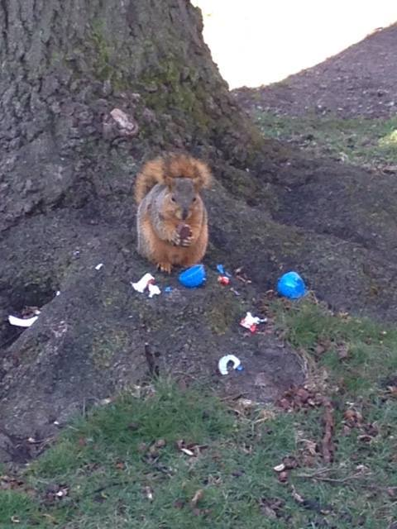
Figure A.1 Campus Gnu Godfrey, enjoying the spoils of an Easter egg hunt. (Photo: Regina Gesicki. Used with permission.)
Future Work
Plans for future surveys and friendly follow-ups are being implemented in conjunction with NDSP with the goal of reducing the number of Gnus attempting to follow students into LaFun.

Bibliography
1. G. Galmira, Gnus and the military – a secret conspiracy? Growing Towards Gnu, III(7): 22–183 (September 1998).
2. G. Gloonston, Newly discovered gnus: The LoG. Growing Towards Gnu, II(12): 23–57 (March 1998).
3. Gnus and Y. T. A. of Being New, Gerry Ganston and Gary Greenfield, volume I. Grapping Books, NY (August 1998).
4. G. Greenfield, Getting to Know Gnu. Ph.D. thesis, Geoffrey Garfield School of Gnus (August 1996).

Footnotes:
This is frequently mistaken for the chattering and scampering away. Gnus are actually quite polite; they will leave if they have nothing nice to say, for fear of saying something offensive.

Base of Operations.

