# Concept Maps

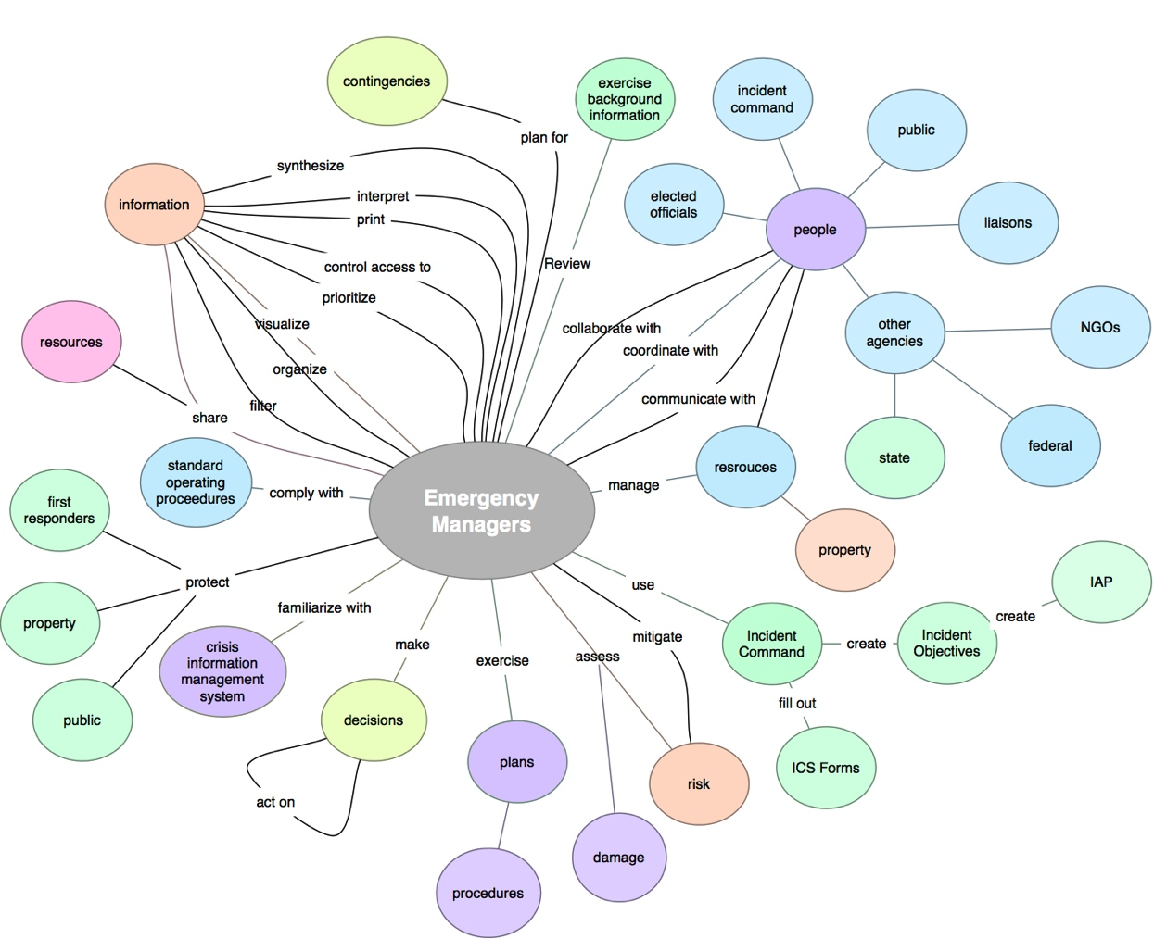

cindys1tbdrive:Users:Cindy:Documents:vEOC Figures:Emergency Manager Concept Map (Implemented).pdf

cindys1tbdrive:Users:Cindy:Documents:vEOC Figures:Exercise Developer Concept Map.pdf

cindys1tbdrive:Users:Cindy:Documents:vEOC Figures:Exercise Developer Concept Map (Implemented).pdf

cindys1tbdrive:Users:Cindy:Documents:vEOC Figures:Exercise Controller Concept Map.pdfcindys1tbdrive:Users:Cindy:Documents:vEOC Documentation:Recent_Materials:vEOC Figures:Exercise Controller Concept Map (Implemented).pdf

cindys1tbdrive:Users:Cindy:Documents:vEOC Figures:Exercise Evaluator Concept Map.pdf

cindys1tbdrive:Users:Cindy:Documents:vEOC Documentation:Recent_Materials:vEOC Figures:Exercise Evaluator Concept Map (Implemented).pdf



