Name:
A-105 Homework 9
Ch. 12 – The Milky Way - 32 points

- (1 pt.) Why is there a period-luminosity relation for Cepheids?

- (1 pt.) How can we use variable stars to find distances?

- (1 pt.) How can we find the age of our galaxy?

- (1 pt.) Why do astronomers conclude that metal-poor stars are older than metal-rich stars?

- (1 pt.) How can we determine the mass of the galaxy?

- (1 pt.) What is the evidence for an extended corona of dark matter?

- (4 pts.) What evidence contradicts the traditional theory for the origin of our galaxy? (At least 4 things.)

- (1 pt.) Why do spiral tracers have to be short-lived?

- (2 pts.) What evidence is there that the density wave theory is not fully adequate to explain spiral arms in our galaxy?

- (1 pt.) What is the evidence that the center of our galaxy contains a massive black hole?

- (1 pt.) Why must astronomers use infrared telescopes to observe the motions of stars around Sgr A*?

- (2 pts.) If the fastest passenger aircraft can fly 1600 km/hr (1000 mph), how many years would it take to reach the sun (in hours)? The Galactic center (in years)? (1 pc km.)

- (2 pts.) In the TV show Star Trek, the fastest the Enterprise can travel is warp 9 (1516 times the speed of light). How long would it take to travel from one end of the galaxy to the other moving at warp 9? What about from our solar system to the Galactic center? (Express your answers in the most intuitive units.)

- (1 pt.) If the Type II Cepheids in a globular cluster have apparent magnitudes of 14 and a period of about 10 days, how far away is the cluster? (Use the distance modulus - Reasoning with Numbers 8-2.)

- (1 pt.) If the RR Lyrae stars in a globular cluster have apparent magnitudes of 14, how far away is the cluster?

- (1 pt.) If a globular cluster is 10 minutes of arc in diameter and 8.5 kpc away, what is its diameter? (Use the small-angle formula.)

- (1 pt.) If the sun is 5 billion years old, how many times has it orbited the galaxy?

- (2 pts.) If the true distance to the center of our galaxy is found to be 7 kpc (instead of 8.5 kpc) and the orbital velocity of the sun is 220 km/s, what is the minimum mass of the galaxy? (Hints: Find the orbital period of the sun at 7 kpc, and then use Kepler’s 3rd law.)

- (1 pt.) Infrared radiation from the center of our galaxy with a wavelength of about m comes mainly from cool stars. Find the temperature of the stars.
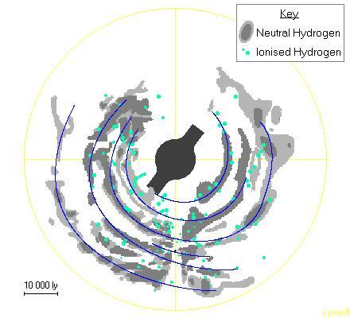

- (6 pts.) Label the spiral arms on the figure of the Milky Way.

