Instructions for using the LambdaCalc program

Mark Behrens
mbehrens@math.uchicago.edu

LambdaCalc is intended to be a calculator for computing with elements of the lambda algebra at all primes. At odd primes, it uses the periodic lambda algebra (see [G]). Of course the subalgebra consisting of the lambdas only is the same in the classical odd primary lambda algebra as the periodic lambda algebra.

This program makes using the tables in [C], [T] easier. The user is advised especially to consult [T] for examples of generating full tags from leading terms. The muli-window environment of LambdaCal is useful because one can cut and paste from one window to the other. Of course, it would be preferable to have these Curtis tables loaded into the program, or better, have the program generate Curtis tables. This is a future project.

- Starting LambdaCalc

LamdaCalc is a single executable (.exe) written in Visual Basic. It runs under windows. Upon running the executable, you should get a window that looks like this:

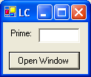

This is the master control window that opens as many calculation windows as you wish. Just enter the prime you wish to work at, and click “Open Window” and a window at the appropriate prime will appear. Additional windows will be opened for each click of “Open Window.” To close the entire program, close the master control window. Closing particular calculation windows will not close the whole program.

- Using calculation windows at p=2

The p=2 calculation window is displayed below.
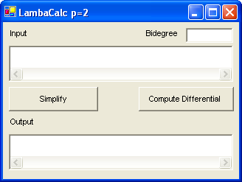

Type (or paste) input in the input window. You input elements of the lambda algebra in the following way. To input the element

λ₃λ₁₂λ₇ + λ₁₀λ₈λ₄

type “3 12 7+10 8 4” into the input box:

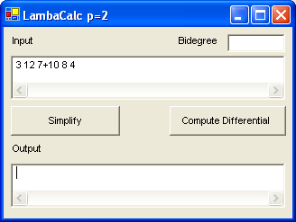

There must be one space between the numbers in the monomials, and no spaces and a “+” between monomials. Elements must be of homogeneous bidegree. Also, if the same monomial appears more than once, these like terms will not be combined, so you are advised to simplify your input by combining like terms.

If you wish to place this element in admissible form, click “Simplify.” The bidegree box will then display the bidegree of the input (as stem, homological degree). The output box will display the admissible representation of the input in the same format. For the above example, the output will be

10 8 4+8 7 7+7 8 7+6 9 7

which should be interpreted as saying that the admissible form of λ₃λ₁₂λ₇ + λ₁₀λ₈λ₄ is

λ₁₀λ₈λ₄ + λ₈λ₇λ₇ + λ₇λ₈λ₇ + λ₆λ₉λ₇

Similarly, the image of the input under the differential is computed by clicking “Compute Differential.”

- Using calculation windows for p>2

The p>2 windows are used similarly to the p=2 windows. The only difference is the format of the input and output. An example of a simplification operation is shown below.

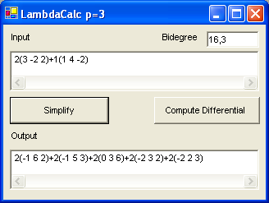

The input should be interpreted as the element

2 λ₃v₂λ₂ + λ₁λ₄v₂

and the output window signifies this element of the 3-primary periodic lambda algebra simplifies to

2 v₁λ₆λ₂ + 2 v₁λ₅λ₃ + 2 v₀λ₃λ₆ + 2 v₂λ₃λ₂ + 2 v₂λ₂λ₃

Note that monomials are separated by “+” without spaces. Each monomial consists of a coefficient (which is not allowed to be 0 mod p) and then a product of generators surrounded by parentheses. Each generator name is separated by a space. If the generator name n is non-positive, then it corresponds to the periodicity element v_{|n|}. If the generator name is positive, it corresponds to the lambda element λ_{n}.

- References

[C] E. Curtis, P. Goerss, M. Mahowald, J. Milgram, Calculations of unstable E₂ terms for
spheres.
[G] B. Gray, The periodic lambda algebra, Fields Institute Communications 19 (1998)
93-101.

[T] M. Tangora, Computing the homology of the lambda algebra, Mem.of the Amer.
Math. Soc. vol. 337.

